BPM - LLD Data Model

Distribution List

Enclosures

Abstract
- Relationships between data
- Details about each table (fields, data type, constraints, required, default values).
- Sample record for each table explaining what can each field contain as a value

Table of Contents
1 Introduction 4
1.1 Purpose 4
1.2 Scope 4
2 Data Models & Methodology 4
2.1 Data Modeling Instance 4
3 Modeling the data 5
3.1 High Level Conceptual Data Model 5
3.2 Contact Entity 5
3.2.1 Data Model 6
3.2.2 Table Details 6
3.2.3 Sample Record 6
3.2.4 Lookups 7
3.2.4.1 Document Type Lookup Table 7
3.2.4.2 Contact Type Lookup Table 7
4 Appendix 7
4.1 Definitions, Acronyms and Abbreviations 7

Revision History

S.No | Date | Change Description | Document Version | Prepared By /Modified By
1 | 20 – Dec - 2018 | Sample Document | 1.0 | Mortada Issa

Introduction
To be filled later.

Purpose
This document is intended to show a sample of the data model low level design to build for the customizations done on BPM solution for ST project.
After Ericsson’s review for this sample, the content of this document will be updated accordingly (including this paragraph).

Scope
The document passes over the data model of BPM solution showing the different customized entities and their relationships. It gets into details of each table (fields, types and sample records).
Important Note: this document does not pass in its diagrams or tables description over all tables in BPM Online. Only the tables and the fields that are customized for ST project are listed. “St” prefix is a naming convention to distinguish between built-in tables and fields and customized ones

Data Models & Methodology

Data Modeling Instance
This document illustrates the data model conceptually. It shows a high level conceptual data model that lists the main tables and the relationships between them.
Then a sub section is intended to show for each main table (contact, line subscription, line moving etc.) the following parts:
- Detailed conceptual data model that focuses on the relationships of the main table with other tables in the system such as lookups and attachments.
- Table showing details about each field (its data type, constraints, required and default value).
- Table showing a sample record with description about each field and what it can contains as values.
- Tables showing details about each lookup used in the main table

Modeling the data

High Level Conceptual Data Model
The module in Figure 1 - High Level Conceptual Data Model shows a high level diagram showing relationships between the different tables customized for ST project. In later sections are more details about each table and its relations at low level (The diagram is not completed yet).
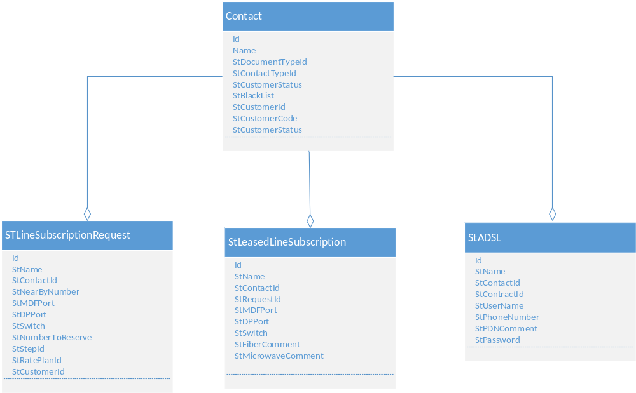
Figure 1 - High Level Conceptual Data Model

Contact Entity
This model shows the contact and its relationships with other entities in the system. For each customer a contact should be created stating his/her basic and additional information (address, attachments, billing data etc.)
Each entity in BPM have an xFile table created to save its attachment in it.
Also for each lookup used in the object, a table with the name of the lookup is created to save lookup values. Such tables usually contains the following columns (ID, Name and Description).

Data Model

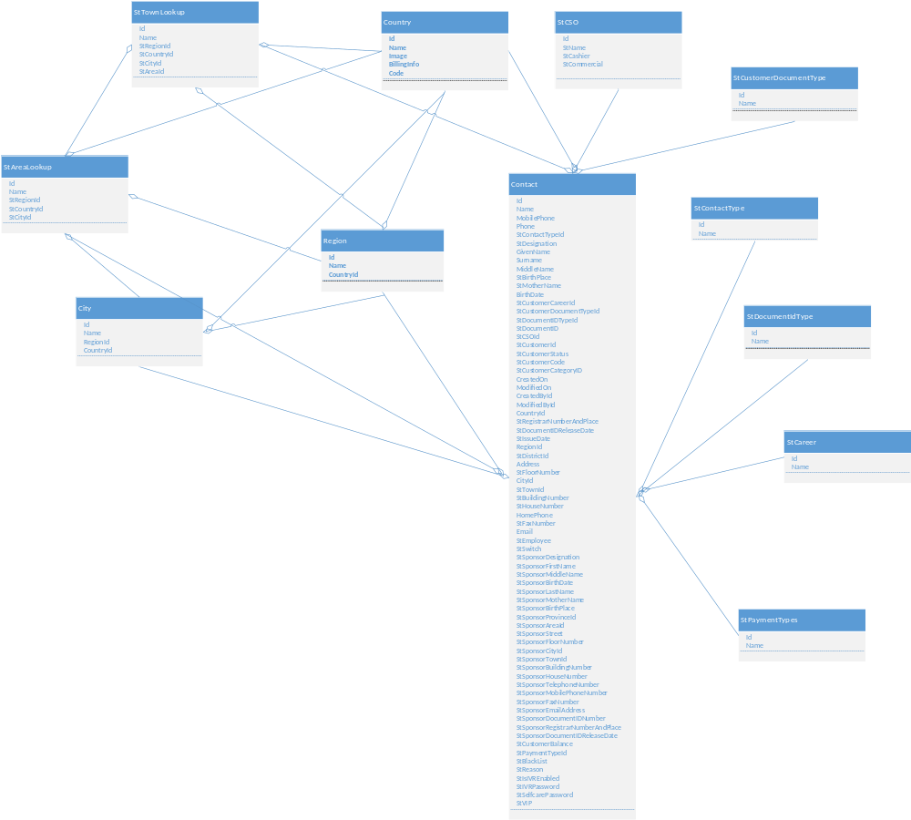

Figure 2 - Contact Table Data Model

Table Details
Table 1 - Contact Table Details
Field | Data Type | Constraint | Required | Default | Source
Id | uniqueidentifier | Primary | Yes
Name | nvarchar(250) |  | Yes
MobilePhone | nvarchar(250)
Phone | nvarchar(250)
StContactTypeId | uniqueidentifier | Foreign | No |  | Lookup
StDesignation | nvarchar(250)
GivenName | nvarchar(250)
Surname | nvarchar(250)
MiddleName | nvarchar(250)
StBirthPlace | nvarchar(250)
StMotherName | nvarchar(250)
BirthDate | date
StCustomerCareerId | uniqueidentifier | Foreign |  |  | Lookup
StCustomerDocumentTypeId | uniqueidentifier | Foreign | No | Syrian | Lookup
StDocumentIDTypeId | uniqueidentifier | Foreign |  |  | Lookup
StDocumentID | nvarchar(250)
StCSOId | uniqueidentifier | Foreign
StCustomerId | nvarchar(250) |  |  |  | BSCS
StCustomerStatus | nvarchar(250) |  |  |  | BSCS
StCustomerCode | nvarchar(250) |  |  |  | BSCS
StCustomerCategoryID | nvarchar(250) |  |  |  | BSCS
CreatedOn | datetime2(3)
ModifiedOn | datetime2(3)
CreatedById | uniqueidentifier
ModifiedById | uniqueidentifier
CountryId | uniqueidentifier | Foreign |  |  | Lookup
StRegistrarNumberAndPlace | nvarchar(250)

Field | Data Type | Constraint | Required | Default | Source
StIssueDate | date
RegionId | uniqueidentifier | Foreign |  |  | Lookup
StDistrictId | uniqueidentifier | Foreign |  |  | Lookup
Address | nvarchar(max)
StFloorNumber | nvarchar(250)
CityId | uniqueidentifier | Foreign |  |  | Lookup
StTownId | uniqueidentifier | Foreign |  |  | Lookup
StBuildingNumber | nvarchar(250)
StHouseNumber | nvarchar(250)
HomePhone | nvarchar(250)
StFaxNumber | nvarchar(250)
Email | nvarchar(250)
StEmployee | bit
StSwitch | nvarchar(250)
StSponsorDesignation | nvarchar(250)
StSponsorFirstName | nvarchar(250)
StSponsorMiddleName | nvarchar(250)
StSponsorBirthDate | nvarchar(250)
StSponsorLastName | nvarchar(250)
StSponsorMotherName | nvarchar(250)
StSponsorBirthPlace | nvarchar(250)
StSponsorProvinceId | uniqueidentifier | Foreign |  |  | Lookup
StSponsorAreaId | uniqueidentifier | Foreign |  |  | Lookup
StSponsorStreet | nvarchar(250)
StSponsorFloorNumber | nvarchar(250)
StSponsorCityId | uniqueidentifier | Foreign |  |  | Lookup
StSponsorTownId | uniqueidentifier | Foreign |  |  | Lookup
StSponsorBuildingNumber | nvarchar(250)

Field | Data Type | Constraint | Required | Default | Source
StSponsorHouseNumber | nvarchar(250)
StSponsorTelephoneNumber | nvarchar(250)
StSponsorMobilePhoneNumber | nvarchar(250)
StSponsorFaxNumber | nvarchar(250)
StSponsorEmailAddress | nvarchar(250)
StSponsorDocumentIDNumber | nvarchar(250)
StSponsorRegistrarNumberAndPlace | nvarchar(250)
StSponsorDocumentIDReleaseDate | date
StCustomerBalance | nvarchar(250) |  |  |  | BSCS
StPaymentTypeId | uniqueidentifier | Foreign |  |  | Lookup
StBlackList | bit
StReason | nvarchar(250)
StIsIVREnabled | bit
StIVRPassword | nvarchar(250)
StSelfcarePassword | nvarchar(250)
StVIP | bit

Table 2 - StCSO table
The table StCSO contains all defined CSOs created by the user. The user is able to add new CSOs when needed.
Field | Data Type | Constraint | Required | Default | Source
Id | uniqueidentifier | Primary
CreatedOn | datetime2(7)
CreatedById | uniqueidentifier
ModifiedOn | datetime2(7)
ModifiedById | uniqueidentifier
StName | Nvarchar(250)
StCashier | bit
StCommercial | bit

Sample Record
A contact can be one of two types: Residential or Individual. Below is an example about a residential contact. An Individual contact can be either “ST employee” or “sponsor” for a foreigner customer

Table 3 - Contact Table Sample Record (RO indicates read-only)
Field | Value | Description
Id | 82F8E7C9-E5C9-4351-9B5F-012593043C5E | The Contact Id in the database
Name | Anas Issam Haddad | The full name of the contact
MobilePhone | 09 780917751 | The contact’s mobile phone ( 9 digits after 09)
Phone | 011 2225854 | The business phone if exists. It is a landline number here (8 or 9 digits after the area code) and it can be mobile phone also.
StContactTypeId | Residential | When creating a contact, a user needs to select one of these two types: either residential contact that has the ability to create requests for him/her, or an individual that will be used as a reference (sponsor or an ST Employee)
StDesignation | Mr | The title prefixing the person’s name
GivenName | Anas | The first name of the contact
Surname | Haddad | The last name of the contact
MiddleName | Issam | The middle name of the contact
StBirthPlace | Damascus | The birth place of the contact
StMotherName | Leila | The name of the contact mother
BirthDate | 29/9/1980 | The birth date of the contact
StCustomerCareerId | Engineer | The contact’s current career
StCustomerDocumentTypeId | Syrian | When creating a contact, one of these types should be selected: Syrian, Military, Syrian-Palestinian and Foreigner.
StDocumentIdTypeId | Personal ID | The type of the document a customer needs to provide for identification. It can be an Id or a passport.
StDocumentID | 6547821399 | The Id of the chosen Document Id type (here the personal Identity number)

Field | Value | Description
StCSOId | Dummar | The CSO related to the CSR
StCustomerId | CUST00000000019 | The customer public key retrieved from BSCS
StCustomerStatus | Active | The customer status retrieved from BSCS and can have one of the following values : Prospect, Active, Blacklisted or deactivated
StCustomerCode | 366 | The customer private key retrieved from BSCS
StCustomerCategoryID | Official | The customer category retrieved from BSCS. Categories are filtered based on customer type (official, enterprise or residential)
CreatedOn | 2018-01-01 8:15 | The creation date and time of the contact file
ModifiedOn | 2018-01-09 10:05 | The date and time of last update of the contact file
CreatedById | Ibrahim Hashem | The user (CSR) who created the contact file.
ModifiedById | Ibrahim Hashem | The user (CSR) who made the last update on the contact file.
CountryId | Syria | The contact’s country
StRegistrarNumberAndPlace | 1551- Zabadani, Barada | The registrar number and place mentioned in the personal ID
StIssueDate | 1/10/1980 | The release date of Personal ID card or Passport (Personal Id in this case)
RegionId | Reef Damascus | The contact address’s province. The value is selected from the dropdown list of regions(provinces)
StDistrictId | Zabadani | The district of the Area of contact address’s province. The value is selected from the dropdown list of Areas
Address | Barada street | The street in the contact address
StFloorNumber | 3 | The floor number in the building address
CityId | Barada | City of the contact’s address. The value is selected from the dropdown list of cities

Field | Value | Description
StTownId | Barada Mosque | The town of the contact address. The value is selected from the dropdown list of Towns
StBuildingNumber | 22 | The building number of the contact’s address
StHouseNumber | 6 | The house number of the contact address
HomePhone | 011 6688932 | Home phone if exists
StFaxNumber | 11 6688932 | Fax number if exists
Email | Anas33@hotmail.com | Email address of the contact
StEmployee | no | This field (flag) is filled only in case of “Individual” contact. If the value is “no“ then the contact is “Individual” - “Sponsor”
StSwitch |  | This column is filled only in case of “Individual -StEmployee” contact. It is mentioned as a reference to the contact’s technical team
StSponsorDesignation |  | This column is filled in case of “Individual” contact for both types: StEmployee and Sponsor. Sponsor is a Syrian resident linked to a foreigner ST customer. Sponsor information is needed since he will be responsible for the foreigner’s account. If a foreigner doesn’t have a sponsor, he should pay a deposit when requesting specific operations as line subscription
StSponsorFirstName |  | The first name of “Individual” contact
StSponsorMiddleName |  | The middle name of “Individual” contact
StSponsorBirthDate |  | The birth date of “Individual” contact
StSponsorLastName |  | The last name of “Individual” contact
StSponsorMotherName |  | The mother name of “Individual” contact
StSponsorBirthPlace |  | The birth place of “Individual” contact
StSponsorProvinceId |  | The province of “Individual” contact’s address.

Field | Value | Description
StSponsorAreaId |  | The area of “Individual” contact’s address.
StSponsorStreet |  | The street of “Individual” contact’s address.
StSponsorFloorNumber |  | The floor number of the address building of “Individual” contact
StSponsorCityId |  | The city of “Individual” contact’s address.
StSponsorTownId |  | The town of “Individual” contact’s address.
StSponsorBuildingNumber |  | The building number of the “Individual” contact’s address
StSponsorHouseNumber |  | The house number of “Individual” contact’s address
StSponsorTelephoneNumber |  | The mobile phone number of “Individual” contact
StSponsorFaxNumber |  | The Fax number of “Individual” contact
StSponsorEmailAddress |  | The email address of “Individual” contact
StSponsorDocumentIDNumber |  | The document number of chosen Document Id Type for “Individual” contact (Passport number or Identity number)
StSponsorRegistrarNumberAndPlace |  | The registrar number and place of “Individual” contact Personal ID
StSponsorDocumentIDReleaseDate |  | The release date of Identity card/Passport of “Individual” contact
StCustomerBalance | 1500 | The total customer balance retrieved from BSCS
StPaymentTypeId | Cash | The payment type selected from one of the two types : Cash or Direct Debit
StBlackList | No | This field (flag) indicates whether the contact is blacklisted or not and can only be filled by the administrator. If Blacklisted, contact is forbidden from requesting services and operations
StReason |  | This text field must contains the description reason behind flagging the contact as “Blacklisted”

Field | Value | Description
StIsIVREnabled | yes | This field(flag) indicates if the IVR usage is enabled for the contact
StIVRPassword | passW0Rd | Password of IVR system account related to the contact
StSelfcarePassword | PaSSW0rd | Password of Selfcare system account related to the contact
StVIP | no | This field(flag) indicates if the contact is flagged “VIP” or not

Lookups

StContactType Lookup Table
Value | Description
Residential | The contact attached to one type of ST customers “Residential”.
Individual | The contact can be used as a reference (Sponsor or an ST Employee)

StCareer Lookup Table

Value | Description
Engineer | The contacts’ career type
Teacher | The contacts’ career type

StCustomerDocumentType Lookup Table

Value | Description
Military | The contact is a Syrian army
Foreigner | The contact is not Syrian
Syrian | The contact is Syrian
Syrian-Palestinian | The contact has two nationalities : Syrian and Palestinian

StDocumentIdType Lookup Table

Value | Description
Passport | The Document Id is the Passport
Personal ID | The Document Id is the Personal ID

Country Lookup Table

Value | Description
Russia
Jordan

Region Lookup Table

Value | Description
Damascus | Syrian Province
Halab | Syrian Province

City Lookup Table

Value | Description
Damascus | City in the Syrian province “Damascus”
Afreen | City in the Syrian province “Halab”

StTownLookup Lookup Table

Value | Description
Kardaha | Town in “Kardaha” area, in “Ladkiya” region

StAreaLookup Lookup Table

Value | Description
Jabal Semaan | area in “Halab” city in “Halab” province

StPaymentTypes Lookup Table

Value | Description
Cash | The customer pays cash invoices
Direct Debit | The customer pays his invoice through the bank

Line Subscription Request Entity
ST customer (having specific pre-conditions) can order a line contract and his request passes through several steps in order to be achieved. Line subscription request is available for these telephony line types: PSTN, ISDN and CDMA.This entity shows all the steps that the request should move through to fulfill the subscription completely.

Data Model

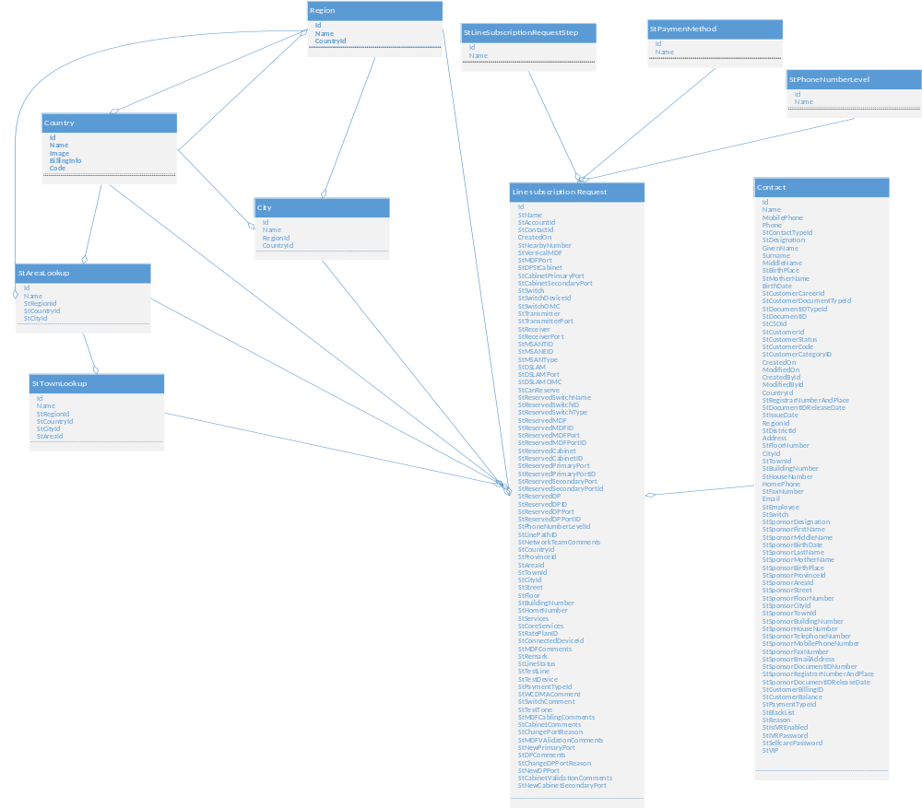

Figure 3 – StLineSubscriptionRequest Table Data Model

Table Details
Table 4 - StLineSubscriptionRequest Table Details
Field | Data Type | Constraint | Required | Default | Source
Id | uniqueidentifier | Primary
StName | nvarchar(250)
StStepId | uniqueidentifier | Foreign |  |  | Lookup
StAccountId | uniqueidentifier | Foreign
StContactId | uniqueidentifier | Foreign
CreatedOn | Datetime2(7)
StNearbyNumber | nvarchar(250)
StVerticalMDF | nvarchar(250) |  |  |  | Inventory
StMDFPort | nvarchar(250) |  |  |  | Inventory
StDP | nvarchar(250) |  |  |  | Inventory
StCabinet | nvarchar(250) |  |  |  | Inventory
StCabinetPrimaryPort | nvarchar(250) |  |  |  | Inventory
StCabinetSecondaryPort | nvarchar(250) |  |  |  | Inventory
StSwitch | nvarchar(250) |  |  |  | Inventory
StSwitchDeviceId | nvarchar(250) |  |  |  | Inventory
StSwitchOMC | nvarchar(250) |  |  |  | Inventory
StTransmitter | nvarchar(250) |  |  |  | Inventory
StTransmitterPort | nvarchar(250) |  |  |  | Inventory
StReceiver | nvarchar(250) |  |  |  | Inventory
StReceiverPort | nvarchar(250) |  |  |  | Inventory
StMSANTID | nvarchar(250) |  |  |  | Inventory

Field | Data Type | Constraint | Required | Default | Source
StMSANEID | nvarchar(250) |  |  |  | Inventory
StMSANType | nvarchar(250) |  |  |  | Inventory
StDSLAM | nvarchar(250) |  |  |  | Inventory
StDSLAMPort | nvarchar(250) |  |  |  | Inventory
StDSLAMOMC | nvarchar(250) |  |  |  | Inventory
StAppointmentDate | datetime2(7)
StReservedSwitchName | nvarchar(250) |  |  |  | Inventory
StReservedSwitchID | nvarchar(250) |  |  |  | Inventory
StReservedSwitchType | nvarchar(250) |  |  |  | Inventory
StReservedMDF | nvarchar(250) |  |  |  | Inventory
StReservedMDFID | nvarchar(250) |  |  |  | Inventory
StReservedMDFPort | nvarchar(250) |  |  |  | Inventory
StReservedMDFPortID | nvarchar(250) |  |  |  | Inventory
StReservedCabinet | nvarchar(250) |  |  |  | Inventory
StReservedCabinetID | nvarchar(250) |  |  |  | Inventory
StReservedPrimaryPort | nvarchar(250) |  |  |  | Inventory
StReservedPrimaryPortID | nvarchar(250) |  |  |  | Inventory
StReservedSecondaryPort | nvarchar(250) |  |  |  | Inventory
StReservedSecondaryPortId | nvarchar(250) |  |  |  | Inventory
StReservedDP | nvarchar(250) |  |  |  | Inventory
StReservedDPID | nvarchar(250) |  |  |  | Inventory
StReservedDPPort | nvarchar(250) |  |  |  | Inventory
StReservedDPPortID | nvarchar(250) |  |  |  | Inventory
StCanReserve | bit
StDPCableLength | decimal(18,2) |  |  |  | Inventory
StPhoneNumberLevelId | uniqueidentifier | Foreign |  |  | Lookup
StLinePathID | nvarchar(250) |  |  |  | Inventory
StNetworkTeamComments | nvarchar(250)

Field | Data Type | Constraint | Required | Default | Source
StCountryId | uniqueidentifier | Foreign | yes |  | Lookup
StProvinceId | uniqueidentifier | Foreign | yes |  | Lookup
StAreaId | uniqueidentifier | Foreign | yes |  | Lookup
StTownId | uniqueidentifier | Foreign | yes |  | Lookup
StCityId | uniqueidentifier | Foreign | yes |  | Lookup
StStreet | nvarchar(250) |  | yes
StFloor | nvarchar(250)
StBuildingNumber | nvarchar(250) |  | yes
StHomeNumber | nvarchar(250)
StServices | nvarchar(250) |  |  |  | BSCS
StCoreServices | nvarchar(250) |  |  |  | BSCS
StRatePlanID | nvarchar(250) |  |  |  | BSCS
StPaymentTypeId | uniqueidentifier | Foreign |  |  | Lookup
StWCDMAComment | nvarchar(250) |  | No
StSwitchComment | nvarchar(250) |  | No
StTestTone | nvarchar(250)
StConnectedDeviceId | nvarchar(250)
StMDFComments | nvarchar(250)
StRemark | nvarchar(250) |  |  |  | Provisioning
StLineStatus | nvarchar(250) |  |  |  | Provisioning
StTestLine | nvarchar(250) |  |  |  | Provisioning
StTestDevice | nvarchar(250) |  |  |  | Provisioning
StMDFCablingComments | nvarchar(250) |  | No
StCabinetComments | nvarchar(250)
StChangePortReason | nvarchar(250)
StMDFVAlidationComments | nvarchar(250) |  | No
StNewPrimaryPort | nvarchar(250) |  |  |  | Inventory
StDPComments | nvarchar(250) |  | No
StChangeDPPortReason | nvarchar(250)

Field | Data Type | Constraint | Required | Default | Source
StNewDPPort | nvarchar(250) |  |  |  | Inventory
StCabinetValidationComments | nvarchar(250) |  | No
StNewCabinetSecondaryPort | nvarchar(250) |  |  |  | Inventory

Sample Record
Table 5 - StLineSubscriptionRequest Table Sample Record (RO indicates read-only)
Field | Value | Description
Id | C679590B-A1FB-45B8-8F89 | The Id of line subscription request in the database
StName | Line Subscription Request For:AnasHaddad | The name of the line subscription request. This field is filled automatically having the format :“Line Subscription Request For : %Contact Name%”
StStepId | Nearby number | The current step in line subscription process
StAccountId | NULL | The Id of the account submitting to the request. This Id is a foreign key from “Account” table. A request can be initiated either for a contact or for an account. One of them filled and the other is NULL
StContactId | D568463D-266C-4B8D-9946-E64FF4AF82C4 | The Id of the contact requesting the line subscription. This Id is a foreign key from the “Contact” table
CreatedOn | 2018-11-05 12:20 | The creation date and time of the line subscription request
StNearbyNumber | 011 3339852 | The nearby number given by the contact submitting to line subscription request in order to find the neighbour reservation and ensure the technical possibility
StVerticalMDF(RO) | 002 | The name of vertical main distribution frame fetched from inventory after requesting line description for the NearbyNumber.

Field | Value | Description
StMDFPort(RO) | P019 | The name of MDF port in the switch fetched from inventory after requesting line description for the NearbyNumber
StDP(RO) | Allepo001.DP | The name of the distribution point fetched from inventory after requesting line description for the NearbyNumber
StCabinet(RO) | Allepo001.CAB | The name of cabinet fetched from inventory after requesting line description for the NearbyNumber
StCabinetPrimaryPort(RO) | P009 | The cabinet port name related to MDF and fetched from inventory after requesting line description for the NearbyNumber
StCabinetSecondaryPort(RO) | P013 | The cabinet port name related to DP fetched from inventory after requesting line description for the NearbyNumber
StSwitch(RO) | Allepo.SW | Switch name is fetched from inventory after requesting line description for the NearbyNumber
StSwitchDeviceId(RO) | 591.0 | Switch device Id is fetched from inventory after requesting line description for the NearbyNumber
StSwitchOMC(RO) | Ericsson | Switch operating and maintenance centre name is fetched from inventory after requesting line description for the NearbyNumber
StTransmitter(RO) | 0 | Transmitter fetched from inventory after requesting line description for the NearbyNumber in case of WCDMA
StTransmitterPort(RO) | 0 | Transmitter’s port fetched from inventory after requesting line description for the NearbyNumber in case of WCDMA

Field | Value | Description
StReceiver(RO) | 0 | Receiver fetched from inventory after requesting line description for the NearbyNumber in case of WCDMA
StReceiverPort(RO) | 0 | Receiver’s port fetched from inventory after requesting line description for the NearbyNumber in case of WCDMA
StMSANTID(RO) |  | Multi-service access node’s terminal identifier. It appears only if NearbyNumber is of type IMS. MSAN terminal Id is fetched from inventory after requesting line description for the NearbyNumber
StMSANEID(RO) |  | Multi-service access node’s equipment identifier. It appears only if NearbyNumber is of type IMS. MSAN device Id is fetched from inventory after requesting line description for the NearbyNumber
StMSANType(RO) |  | Multi-service access node’s type. It appears only if the NearbyNumber is of type IMS. MSAN type Id is fetched from after requesting line description for the NearbyNumber and can be one of the two types: Combo or POTS
StDSLAM(RO) |  | DSL access multiplexer’s name. It appears only if the NearbyNumber is of type PSTN/ISDN with ADSL. DSLAM is fetched from inventory after requesting line description for the NearbyNumber
StDSLAMPort(RO) |  | DSL access multiplexer’s port. It appears only if the NearbyNumber is of type PSTN/ISDN with ADSL. DSLAM port is fetched from inventory after requesting line description for the NearbyNumber

Field | Value | Description
StDSLAMOMC(RO) |  | DSL access multiplexer’s OMC. It appears only if the NearbyNumber is of type PSTN/ISDN with ADSL. DSLAM OMC is fetched from inventory after requesting line description for the NearbyNumber
StAppointmentDate | 2018-11-13 09:00 | Appointment date given to the customer to proceed with technical implementation of line subscription
StReservedSwitchName(RO) | Allepo.SW | Reserved switch name is fetched from inventory after applying free phone number reservation
StReservedS  witchID(RO) | 591.0 | Reserved switch Id is fetched from inventory after applying free phone number reservation
StReservedSwitchType(RO) | Automatic | Reserved switch type is fetched from inventory after applying free phone number reservation
StReservedMDF(RO) | Allepo001.MDF | Reserved MDF name is fetched from inventory after applying free phone number reservation
StReservedMDFID(RO) | 600.0 | Reserved MDF Id is fetched from inventory after applying free phone number reservation
StReservedMDFPort(RO) | P005 | Reserved MDF port name is fetched from inventory after applying free phone number reservation
StReservedMDFPortID(RO) | 678.0 | Reserved MDF port Id is fetched from inventory after applying free phone number reservation
StReservedCabinet(RO) | Allepo001.CAB | Reserved cabinet name is fetched from inventory after applying free phone number reservation
StReservedCabinetID(RO) | 608.0 | Reserved cabinet Id is fetched from inventory after applying free phone number reservation
StReservedPrimaryPort(RO) | P005 | Reserved cabinet primary port name is fetched from inventory after applying free phone number reservation

Field | Value | Description
StReservedPrimaryPortID(RO) | 675.0 | Reserved cabinet primary port Id is fetched from inventory after applying free phone number reservation
StReservedSecondaryPort(RO) | S005 | Reserved cabinet secondary port name is fetched from inventory after applying free phone number reservation
StReservedSecondaryPortId(RO) | 676.0 | Reserved cabinet secondary port Id is fetched from inventory after applying free phone number reservation
StReservedDP(RO) | Allepo001.DP | Reserved DP name is fetched from inventory after applying free phone number reservation
StReservedDPID(RO) | 619.0 | Reserved DP Id is fetched from inventory after applying free phone number reservation
StReservedDPPort(RO) | P005 | Reserved DP port name is fetched from inventory after applying free phone number reservation
StReservedDPPortID(RO) | 677.0 | Reserved DP port Id is fetched from inventory after applying free phone number reservation
StCanReserve | yes | Field flag to indicates that there is a technical reservation possibility
StDPCableLength | 0.6 | The cable length selected by DP team
StPhoneNumberLevelId | Silver | The CSR selects the needed phone number level from a dropdown list to get related free numbers. Phone number levels are : Normal, Silver, Gold and Platinum
StLinePathID |  | This field assembles information related to reserved line technical info (DP-Cabinet- MDF- Switch)
StNetworkTeamComments |  | Optional field to add comments by the network team after selecting the line path ID
StCountryId | Syria

Field | Value | Description
StProvinceId | Reef Damascus | Province of the line subscription request address
StAreaId | Zabadani | Area of the line subscription request address
StTownId | Barada Mosque | Town of the line subscription request address
StCityId | Barada | City of the line subscription request address
StStreet | Barada Street | Street of the line subscription request address
StFloor | 4 | Floor number of the line subscription request address’s building
StBuildingNumber | 6 | Building number of the line subscription request address
StHomeNumber | 7 | Home number of the line subscription request address
StRatePlanID |  | The CSR selects rate plan (based on contact category) from allowed rate plans
StServices | {"Call Barring, Call Clearing”} | This field contains the services displayed (from BSCS) after selecting the rate plan
StCoreServices
StPaymentTypeId | invoice | The payment method selected for the line subscription fee. It can be either “Cash” or “invoice”
StWCDMAComment |  | Optional field to add comments by WCDMAC team
StSwitchComment |  | Optional field to add comments by switch team
StTestTone |  | This is the result of testing the tone on the reserved switch after activating “test tone” mode on the switch interface
StLineStatus
StTestLine
StTestDevice
StRemark

Field | Value | Description
StMDFCablingComments |  | Optional field to add comments by MDF team related to his cabling work on boards(link ports in MDF)
StCabinetComments |  | Optional field to add comments by cabinet team and send them to MDF team in order to update the linked ports
StChangePortReason |  | The reason behind changing the reserved port and written by cabinet team
StMDFVAlidationComments |  | Optional field to add comments by MDF team after releasing the old primary port
StNewPrimaryPort | P012 | New mapped cabinet primary port for reservation after MDF team receives the request from cabinet team in case of changing cabinet primary port
StDPComments |  | Optional field to add comments by DP team while sending the request back to cabinet team to update the linked ports on secondary
StChangeDPPortReason |  | The reason behind changing the reserved DP port and written by the DP team
StNewDPPort |  | New selected DP port for reservation fetched from inventory
StCabinetValidationComments |  | Optional field to add comments by cabinet team
StNewCabinetSecondaryPort |  | New mapped cabinet secondary port for reservation after cabinet team receives the request from DP team to update linked ports on secondary

Lookups

StPaymentMethod Lookup Table
Value | Description
Cash | The customer pays cash the line subscription request’s fee
Invoice | The customer pays line subscription request’s fee on invoice

StLineSubscriptionRequestStep Lookup Table

Value | Description
Nearby Number | Nearby number step in line subscription request. A nearby number is added and related technical description is fetched from inventory
Find Free Technical Possibility | Step of finding free phone numbers to reserve in line subscription request process

StPhoneNumberLevel Lookup Table

Value | Description
Normal
Gold
Silver
Platinum

Country Lookup Table

Value | Description
Syria | The default value is Syria

Region Lookup Table

Value | Description
Damascus | Syrian Province
Halab | Syrian Province

City Lookup Table

Value | Description
Damascus | City in the Syrian province “Damascus”
Afreen | City in the Syrian province “Halab”

StTownLookup Lookup Table

Value | Description
Kardaha | Town in “Kardaha” area, in “Ladkiya” region

StAreaLookup Lookup Table

Value | Description
Jabal Semaan | area in “Halab” city in “Halab” province

Telephony Line Termination Entity

Telephony line termination is one of the allowed operations in CRM. When a customer needs to terminate his phone line contract with ST, he requests a Line termination operation

Data Model

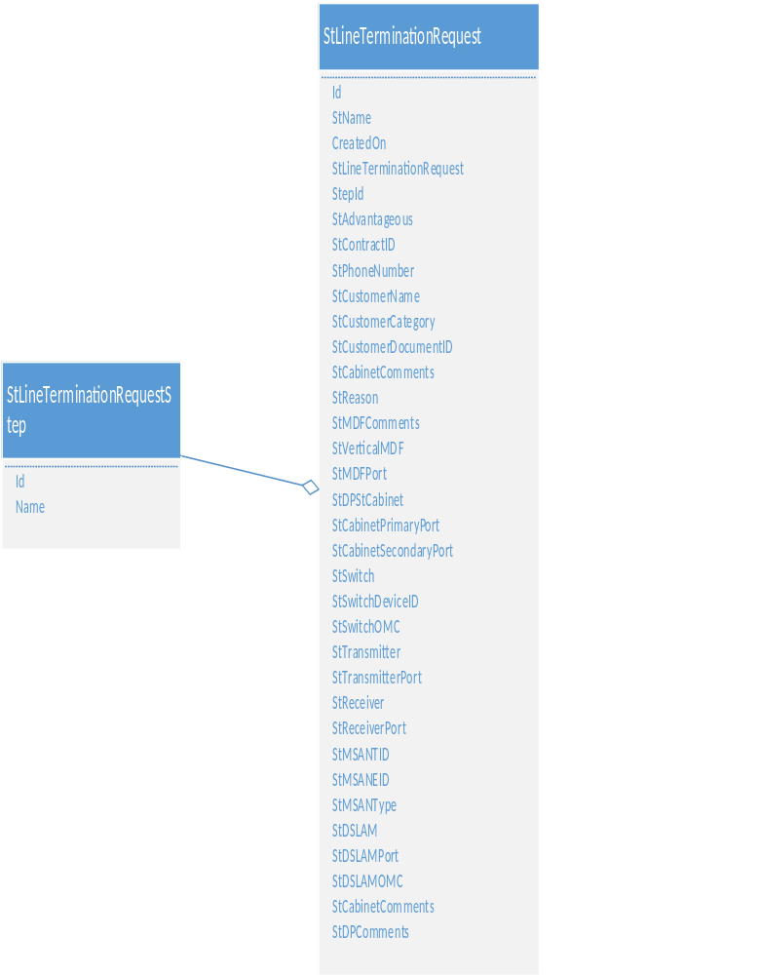

Figure 4 – StLineTerminationRequest Table Data Model

Table Details

Table 6 – StLineTerminationRequest Table Details
Field | Data Type | Constraint | Required | Default | Source
Id | uniqueidentifier | Primary
StName | nvarchar(250)
CreatedOn | Datetime2(7)
StLineTerminationRequestStepId | uniqueidentifier | Foreign |  |  | Lookup
StAdvantageous | bit
StContractID | nvarchar(250) |  |  |  | BSCS
StPhoneNumber | nvarchar(250)
StCustomerName | nvarchar(250)
StCustomerCategory | nvarchar(250) |  |  |  | BSCS
StCustomerDocumentID | nvarchar(250)
StCabinetComments | nvarchar(250)
StReason | nvarchar(250)
StMDFComments | nvarchar(250)
StVerticalMDF | nvarchar(250) |  |  |  | Inventory
StMDFPort | nvarchar(250) |  |  |  | Inventory
StDP | nvarchar(250) |  |  |  | Inventory
StCabinet | nvarchar(250) |  |  |  | Inventory
StCabinetPrimaryPort | nvarchar(250) |  |  |  | Inventory
StCabinetSecondaryPort | nvarchar(250) |  |  |  | Inventory

Field | Data Type | Constraint | Required | Default | Source
StSwitch | nvarchar(250) |  |  |  | Inventory
StSwitchDeviceID | nvarchar(250) |  |  |  | Inventory
StSwitchOMC | nvarchar(250) |  |  |  | Inventory
StTransmitter | nvarchar(250) |  |  |  | Inventory
StTransmitterPort | nvarchar(250) |  |  |  | Inventory
StReceiver | nvarchar(250) |  |  |  | Inventory
StReceiverPort | nvarchar(250) |  |  |  | Inventory
StMSANTID | nvarchar(250) |  |  |  | Inventory
StMSANEID | nvarchar(250) |  |  |  | Inventory
StMSANType | nvarchar(250) |  |  |  | Inventory
StDSLAM | nvarchar(250) |  |  |  | Inventory
StDSLAMPort | nvarchar(250) |  |  |  | Inventory
StDSLAMOMC | nvarchar(250) |  |  |  | Inventory
StCabinetComments | nvarchar(250)
StDPComments | nvarchar(250)

Sample Record

Table 7 – StLineTerminationRequest Table Sample Record (RO indicates read-only)
Field | Value | Description
Id | 2804D709-D009-4092-BE28-2A8343FBD647 | The Id of the line termination operation
StName | Line Termination Request For contract:  CONTR0000000315 | The name of the line termination operation
CreatedOn | 2018-10-10 09:00 | The date and time of creation of line termination operation request
StLineTerminationRequestStepId | MDF team | The step in the termination process. This field is used for routing the process steps
StAdvantageous | no | This field indicates whether the operation is advantageous or not. If yes, operation can continue despite positive balance for residential and enterprise
StContractID | CONTR0000000315 | The contract Id related to the line termination request
StPhoneNumber | 11 6667778 | The telephone number to be terminated
StCustomerName | Anas Haddad | The customer name
StCustomerCategory | official | The customer category retrieved from BSCS
StCustomerDocumentID | 17485998543 | The Id of the chosen document type (here the personal Identity number)
StCabinetComments |  | The related Cabinet team comments
StReason | migration | The reason of line termination request
StMDFComments |  | The related MDF team comments
StVerticalMDF(RO) | 001 | vertical MDF name related to the telephone number to be terminated
StMDFPort(RO) | P008 | MDF port related to the telephone number to be terminated
StDP(RO) | Midan001.DP | DP name related to the telephone number to be terminated
StCabinet(RO) | Midan002.CAB | Cabinet name related to the telephone number to be terminated

Field | Value | Description
StCabinetPrimaryPort(RO) |  | Cabinet name related to the telephone number to be terminated
StCabinetSecondaryPort(RO) |  | Cabinet name related to the telephone number to be terminated
StSwitch(RO) |  | Cabinet name related to the telephone number to be terminated
StSwitchDeviceID(RO) |  | Cabinet name related to the telephone number to be terminated
StSwitchOMC(RO) |  | Cabinet name related to the telephone number to be terminated
StTransmitter(RO) |  | Cabinet name related to the telephone number to be terminated
StTransmitterPort(RO) |  | Cabinet name related to the telephone number to be terminated
StReceiver(RO) |  | Cabinet name related to the telephone number to be terminated
StReceiverPort(RO) |  | Cabinet name related to the telephone number to be terminated
StMSANTID(RO) |  | Cabinet name related to the telephone number to be terminated
StMSANEID(RO) |  | Cabinet name related to the telephone number to be terminated
StMSANType(RO) |  | Cabinet name related to the telephone number to be terminated
StDSLAM(RO) |  | Cabinet name related to the telephone number to be terminated

Field | Value | Description
StDSLAMPort(RO) |  | Cabinet name related to the telephone number to be terminated
StDSLAMOMC(RO) |  | Cabinet name related to the telephone number to be terminated
StCabinetComments |  | Comments written by cabinet team
StDPComments |  | Comments written by DP team

Lookups

StLineTerminationRequestStep Lookup Table

Value | Description
Reason | In this step, CSR write the reason to line termination request
Generate Invoice | Generate invoice in line termination process in case of payment method was on invoice. The invoice is generated via BOD process after CRM validates the BOD payment

Line Moving Same Switch Request Entity

This entity represents the case when the customer having telephony line subscription wants to move to a different location but within the same switch range.

Data Model

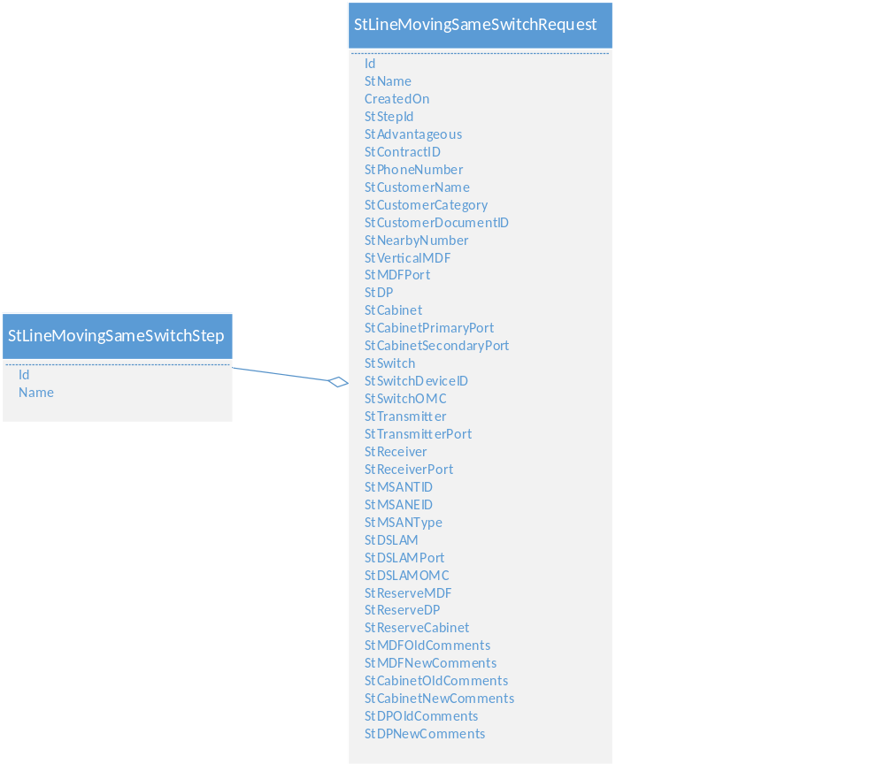

Figure 5 – StLineMovingSameSwitchRequest Table Data Model

Table Details

Table 8 – StLineMovingSameSwitchRequest Table Details
Field | Data Type | Constraint | Required | Default | Source
Id | uniqueidentifier | Primary
StName | nvarchar(250)
CreatedOn | datetime2(7)
StAdvantageous | bit
StStepId | uniqueidentifier | Foreign
StContractID | nvarchar(250) |  |  |  | BSCS
StPhoneNumber | nvarchar(250)
StCustomerName | nvarchar(250) |  |  |  | BSCS
StCustomerCategory | nvarchar(250) |  |  |  | BSCS
StCustomerDocumentID | nvarchar(250)
StNearbyNumber | nvarchar(250) |  |  |  | Inventory
StVerticalMDF | nvarchar(250) |  |  |  | Inventory
StMDFPort | nvarchar(250) |  |  |  | Inventory
StDP | nvarchar(250) |  |  |  | Inventory
StCabinet | nvarchar(250) |  |  |  | Inventory
StCabinetPrimaryPort | nvarchar(250) |  |  |  | Inventory
StCabinetSecondaryPort | nvarchar(250) |  |  |  | Inventory
StSwitch | nvarchar(250) |  |  |  | Inventory
StSwitchDeviceID | nvarchar(250) |  |  |  | Inventory
StSwitchOMC | nvarchar(250) |  |  |  | Inventory

Field | Data Type | Constraint | Required | Default | Source
StTransmitter | nvarchar(250) |  |  |  | Inventory
StTransmitterPort | nvarchar(250) |  |  |  | Inventory
StReceiver | nvarchar(250) |  |  |  | Inventory
StReceiverPort | nvarchar(250) |  |  |  | Inventory
StMSANTID | nvarchar(250) |  |  |  | Inventory
StMSANEID | nvarchar(250) |  |  |  | Inventory
StMSANType | nvarchar(250) |  |  |  | Inventory
StDSLAM | nvarchar(250) |  |  |  | Inventory
StDSLAMPort | nvarchar(250) |  |  |  | Inventory
StDSLAMOMC | nvarchar(250) |  |  |  | Inventory
StReserveMDF | nvarchar(250) |  |  |  | Inventory
StReserveDP | nvarchar(250) |  |  |  | Inventory
StReserveCabinet | nvarchar(250) |  |  |  | Inventory
StMDFOldComments | nvarchar(250)
StMDFNewComments | nvarchar(250)
StCabinetOldComments | nvarchar(250)
StCabinetNewComments | nvarchar(250)
StDPOldComments | nvarchar(250)
StDPNewComments | nvarchar(250)

Sample Record

Table 9 – StLineMovingSameSwitchRequest Table Sample Record (RO indicates read-only)

Field | Value | Description
Id | B4D92253-3351-40F3-BA6B-ECBDF08849B8 | The Id of line moving same switch request
StName | Line Moving Same Switch For contract: CONTR0000000312 | The name of line moving same switch request
CreatedOn | 2018-10-29 11:30 | The creation date of line moving same switch request
StAdvantageous | no
StStepId | Temporary Reservation | The step in “line moving same switch request” process
StContractID | CONTR0000000312 | The contract Id of the related line
StPhoneNumber | 011 8884441 | The number of the line to be moved
StCustomerName | Anas Haddad | The name of the customer requesting the line moving
StCustomerCategory | Active | The customer category retrieved from BSCS
StCustomerDocumentID | 11235998544 | The Id of the chosen document type (here the personal Identity number)
StNearbyNumber | 011 5553337 | The nearby number given by the customer in order to find the neighbour technical reservation related to the new address for the line to be moved
StVerticalMDF (RO) | 003 | The vertical MDF related to the nearby number
StMDFPort(RO) | P018 | The MDF port related to the nearby number
StDP(RO) | Allepo001.DP | The DP related to the nearby number
StCabinet(RO) | Allepo001.CAB | The cabinet related to the nearby number

Field | Value | Description
StCabinetPrimaryPort(RO) |  | The cabinet’s primary port related to the nearby number
StCabinetSecondaryPort(RO) |  | The cabinet’s secondary port related to the nearby number
StSwitch(RO) | Allepo.SW | The switch related to the nearby number
StSwitchDeviceID(RO) | 591.0 | The switch’s device Id related to the nearby number
StSwitchOMC(RO) | Ericsson | The switch’s operating and maintenance centre related to the nearby number
StTransmitter(RO) | 0 | This field have value only if the nearby number is of type WCDMA
StTransmitterPort(RO) | 0 | This field have value only if the nearby number is of type WCDMA
StReceiver(RO) | 0 | This field have value only if the nearby number is of type WCDMA
StReceiverPort(RO) | 0 | This field have value only if the nearby number is of type WCDMA
StMSANTID(RO) |  | This field appears only if the nearby number is of type IMS
StMSANEID(RO) |  | This field appears only if the nearby number is of type IMS
StMSANType(RO) |  | This field appears only if the nearby number is of type IMS
StDSLAM(RO) |  | This field appears only if the nearby number is of type PSTN/ISDN with ADSL
StDSLAMPort(RO) |  | This field appears only if the nearby number is of type PSTN/ISDN with ADSL. It should have the same value in case the line to be moved have ADSL service active
StDSLAMOMC(RO) |  | This field appears only if the nearby number is of type PSTN/ISDN with ADSL

Field | Value | Description
StReserveMDF(RO) | 020 | The free reserved MDF returned by inventory API. If it is different from old reservation, old reservation is released in old MDF
StReserveDP(RO) | Allepo002.DP | The free reserved DP returned by inventory API. If it is different from old reservation, old reservation is released in old DP
StReserveCabinet(RO) | Allepo001.CAB | The free reserved cabinet returned by inventory API. If it is different from old reservation, old reservation is released in old cabinet
StMDFOldComments |  | The comments written by the team of old MDF
StMDFNewComments |  | The comments written by the team of new MDF
StCabinetOldComments |  | The comments written by the team of old cabinet
StCabinetNewComments |  | The comments written by the team of new cabinet
StDPOldComments |  | The comments written by the team of old DP
StDPNewComments |  | The comments written by the team of new DP

Lookups

StLineMovingSameSwitchStep Lookup Table

Value | Description
Nearby Number | Fetching technical description for nearby number in line moving same switch process
MDF new | Reserve new MDF step in line moving same switch process

Change Phone Number Request Entity

This entity represents the change phone number operation requested by the customer where the same contract will be kept but with other technical resources.

Data Model

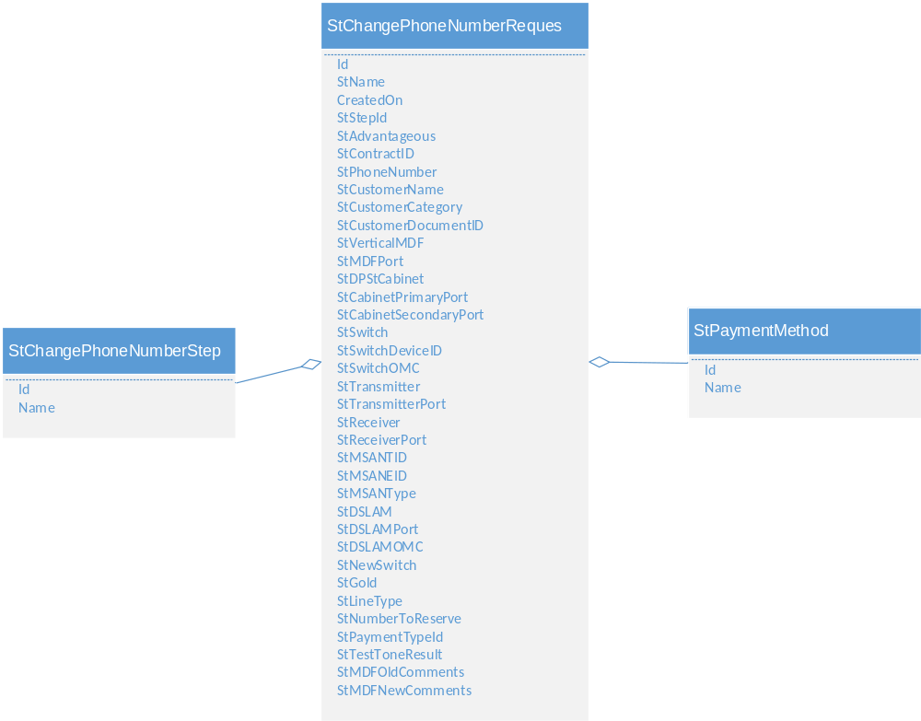
Figure 6 – StChangePhoneNumberRequest Table Data Model

Table Details

Table10 - StChangePhoneNumberRequest Table Details

Field | Data Type | Constraint | Required | Default | Source
Id | uniqueidentifier | Primary
StName | nvarchar(250)
CreatedOn | Datetime2(7)
StStepId | uniqueidentifier | Foreign
StAdvantageous | bit
StContractID | nvarchar(250) |  |  |  | BSCS
StPhoneNumber | nvarchar(250)
StCustomerName | nvarchar(250) |  |  |  | BSCS
StCustomerCategory | nvarchar(250) |  |  |  | BSCS
StCustomerDocumentID | nvarchar(250)
StVerticalMDF | nvarchar(250) |  |  |  | Inventory
StMDFPort | nvarchar(250) |  |  |  | Inventory
StDP | nvarchar(250) |  |  |  | Inventory
StCabinet | nvarchar(250) |  |  |  | Inventory
StCabinetPrimaryPort | nvarchar(250) |  |  |  | Inventory
StCabinetSecondaryPort | nvarchar(250) |  |  |  | Inventory
StSwitch | nvarchar(250) |  |  |  | Inventory
StSwitchDeviceID | nvarchar(250) |  |  |  | Inventory
StSwitchOMC | nvarchar(250) |  |  |  | Inventory

Field | Data Type | Constraint | Required | Default | Source
StTransmitter | nvarchar(250) |  |  |  | Inventory
StTransmitterPort | nvarchar(250) |  |  |  | Inventory
StReceiver | nvarchar(250) |  |  |  | Inventory
StReceiverPort | nvarchar(250) |  |  |  | Inventory
StMSANTID | nvarchar(250) |  |  |  | Inventory
StMSANEID | nvarchar(250) |  |  |  | Inventory
StMSANType | nvarchar(250) |  |  |  | Inventory
StDSLAM | nvarchar(250) |  |  |  | Inventory
StDSLAMPort | nvarchar(250) |  |  |  | Inventory
StDSLAMOMC | nvarchar(250) |  |  |  | Inventory
StNewSwitch | bit |  |  |  | Inventory
StGold | bit
StLineType | nvarchar(250)
StNumberToReserve | nvarchar(250) |  |  |  | Inventory
StPaymentTypeId | uniqueidentifier | Foreign
StTestToneResult | nvarchar(250) |  |  |  | Provisioning
StMDFOldComments | nvarchar(250)
StMDFNewComments | nvarchar(250)

Sample Record

Table 21 – StChangePhoneNumberRequest Table Sample Record (RO indicates read-only)
Field | Value | Description
Id | D4D4FAA5-634C-4767-A954-7F735FF1F638 | The Id for changing number request
StName | Change Phone Number For contract: CONTR0000000219 | The name for changing number request
CreatedOn | 2018-10-29 | The creation date of changing number request
StAdvantageous | No
StStepId | Choose phone number | The step in changing phone number process
StContractID | CONTR0000000219 | The related contract Id for the phone number to be changed
StPhoneNumber | 011 2223537 | The phone number submitting to changing number request
StCustomerName | Anas Haddad | The customer name requesting change phone number operation
StCustomerCategory | citizen | The customer category retrieved from BSCS
StCustomerDocumentID | 1554896532 | The customer document Id for the chosen document type (Passport or Identity)
StVerticalMDF |  | Vertical MDF related to the current phone number
StMDFPort |  | MDF port related to the current phone number
StDP |  | DP related to the current phone number
StCabinet |  | Cabinet related to the current phone number
StCabinetPrimaryPort |  | Cabinet primary port related the current phone number
StCabinetSecondaryPort |  | Cabinet secondary port related to the current phone number
StSwitch |  | Switch related to the current phone number

Field | Value | Description
StSwitchDeviceID |  | Switch device Id related to the current phone number
StSwitchOMC |  | Switch OMC related to the current phone number
StTransmitter |  | Transmitter related to the current phone number
StTransmitterPort |  | Transmitter port related to the current phone number
StReceiver |  | Receiver related to the current phone number
StReceiverPort |  | Receiver port related to the current phone number
StMSANTID |  | Technical description for the current phone number
StMSANEID |  | Technical description for the current phone number
StMSANType |  | Technical description for the current phone number
StDSLAM |  | Technical description for the current phone number
StDSLAMPort |  | Technical description for the current phone number
StDSLAMOMC |  | Technical description for the current phone number
StNewSwitch |  | Flag field to choose if the new phone number belongs to another switch
StGold |  | Flag field to choose if the new phone number have “Gold” level
StLineType | PSTN | This field contains drop down list of line types for the current phone number
StNumberToReserve | 011 2225587 | The number to reserve fetched from inventory and selected from a dropdown list of available free numbers

Field | Value | Description
StPaymentTypeId | cash | The selected payment method (cash or invoice) of the changing phone number request’s fee
StTestToneResult |  | The result written by provisioning team after activating “test tone” mode on the intended switch interface
StMDFOldComments |  | Comments written by the old MDF team
StMDFNewComments |  | Comments written by the new MDF team

Lookups

StChangePhoneNumberStep Lookup Table
Value | Description
Choose phone number | Choosing the new phone number step in changing phone number process
Payment | Payment step in changing phone number process

StPaymentMethod Lookup Table

Value | Description
Cash | The customer pays cash the request’s fee
Invoice | The customer pays change phone number request’s fee on invoice

Line Blocking Operation Entity
A contract is marked as “blocked” based on official or judicial decision. To perform this operation, CRM should not validate the balance. In addition, an official document should be attached to complete the process.

Data Model

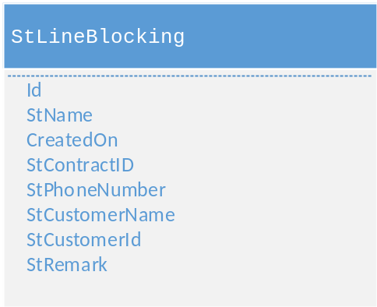

Figure 7 – StLineBlocking Table Data Model

Table Details
Table12- StLineBlocking Table Details

Field | Data Type | Constraint | Required | Default | Source
Id | uniqueidentifier | Primary
StName | nvarchar(250)
CreatedOn | datetime2(7)
StContractID | nvarchar(250) |  |  |  | BSCS
StPhoneNumber | nvarchar(250)
StCustomerName | nvarchar(250)
StRemark | nvarchar(250)
StCustomerId | nvarchar(250) |  |  |  | BSCS

Sample Record
Table13- StLineBlocking Table Sample Record (RO indicates read-only)
Field | Value | Description
Id | 902DA745-34BD-439F-A032-6F0C7F39A78E | The Id of the line blocking operation
StName | Line Blocking Request for: CONTR0000000115 | The name of the line blocking operation
CreatedOn | 2018-10-31 11:50 | The creation date and time of the blocking operation
StContractID | CONTR0000000115 | The Id of the contract to be marked as “blocked”
StPhoneNumber | 011 2235589 | The phone number to be blocked

Field | Value | Description
StCustomerName | Anas Haddad | The customer name owning the contract to be marked as “blocked”
StRemark |  | The official attachment that describes the reason and decision of blocking
StCustomerId | CUST0000000123 | The customer public key retrieved from BSCS

Lookups

Currently there is no lookups for this entity.

Line Unblocking Operation Entity

Similar to line blocking operation, an official or judicial decision is needed to release the contract from being blocked and an official document should be attached to complete the process.

Data Model

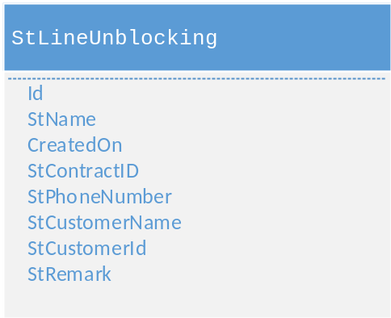

Figure 8 – StLineUnblocking Table Data Model

Table Details
Table14- StLineUnblocking Table Details

Field | Data Type | Constraint | Required | Default | Source
Id | uniqueidentifier | Primary
StName | nvarchar(250)
CreatedOn | datetime2(7)
StContractID | nvarchar(250) |  |  |  | BSCS
StPhoneNumber | nvarchar(250)
StCustomerName | nvarchar(250)
StRemark | nvarchar(250)
StCustomerId | nvarchar(250) |  |  |  | BSCS

Sample Record
Table15- StLineUnblocking Table Sample Record (RO indicates read-only)

Field | Value | Description
Id | 902DA745-34BD-439F-A032-6F0C7F39A78E | The Id of the line unblocking operation
StName | Line UnBlocking Request for: CONTR0000000122 | The name of the line unblocking operation
CreatedOn | 2018-10-31 13:00 | The creation date and time of the unblocking operation
StContractID | CONTR0000000122 | The Id of the contract to be released from blocking
StPhoneNumber | 011 3336667 | The phone number to be unblocked
StCustomerName | Anas Haddad | The customer name owning the contract to be released from blocking
StRemark |  | The official attachment that describes the reason and decision of unblocking
StCustomerId | CUST0000000330 | The customer public key retrieved from BSCS

Lookups

Currently there is no lookups for this entity.

Change Rate Plan Entity

This operation is used after changing customer category and in some cases after changing phone number type, for example changing ISDN to PSTN and vice versa. CRM shows a list of allowed rate plans and CSR selects the target one.

Data Model

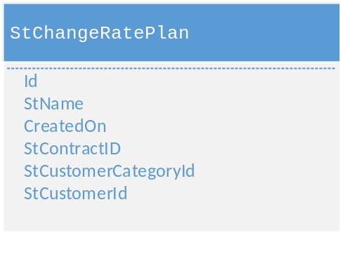

Figure 9 – StChangeRatePlan Table Data Model

Table Details
Table16- StChangeRatePlan Table Details

Field | Data Type | Constraint | Required | Default | Source
Id | uniqueidentifier | Primary
StName | nvarchar(250)
CreatedOn | datetime2(7)
StContractID | nvarchar(250) |  |  |  | BSCS
StCustomerCategoryId | nvarchar(250) |  |  |  | BSCS
StCustomerId | nvarchar(250) |  |  |  | BSCS

Sample Record
Table17- StLineUnblocking Table Sample Record (RO indicates read-only)

Field | Value | Description
Id | 902DA745-34BD-439F-A032-6F0C7F39A78E | The Id of changing rate plan operation
StName | Change RatePlan Request for: CONTR0000000123 | The name of changing rate plan operation
CreatedOn | 2018-10-31 08:25 | The creation date and time of changing rate plan operation
StContractID | CONTR0000000123 | The Id of the contract submitting to change rate plan operation
StCustomerCategoryId | Citizen | The customer category owning the contract submitting to change rate plan operation
StCustomerId | CUST0000000225 | The customer public key retrieved from BSCS

Lookups
Currently there is no lookups for this entity.

Line moving New Switch Request Entity

This entity represents the case when the customer having telephony line subscription wants to move to a different location outside the switch range.

Data Model

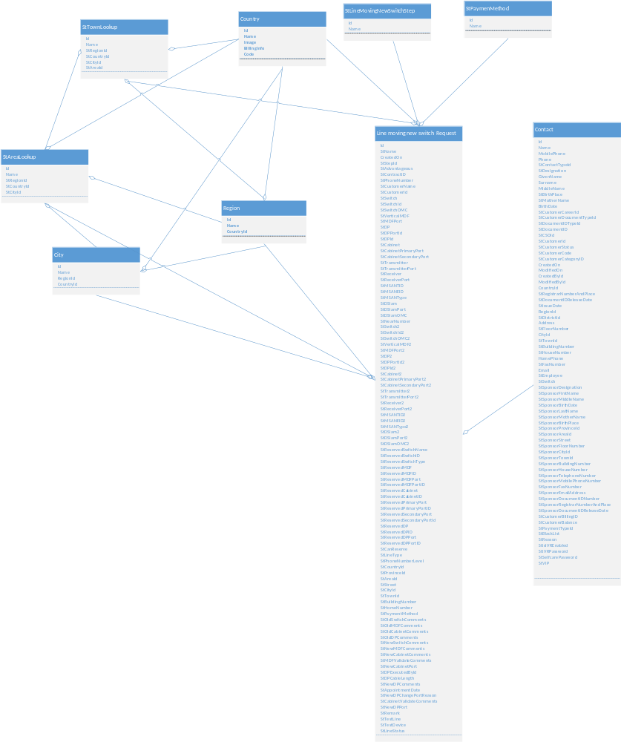

Figure 10- StLineMovingNewSwitch Table Data Model

Table Details
Table18- StLineMovingNewSwitch Table Details

Field | Data Type | Constraint | Required | Default | Source
Id | uniqueidentifier | Primary
StName | nvarchar(250)
CreatedOn | datetime2(7)
StStepId | uniqueidentifier | Foreign |  |  | Lookup
StContractID | nvarchar(250) |  |  |  | BSCS
StAdvantageous | bit
StPhoneNumber | nvarchar(250)
StCustomerName | nvarchar(250) |  |  |  | BSCS
StCustomerId | nvarchar(250) |  |  |  | BSCS
StSwitch | nvarchar(250) |  |  |  | Inventory
StSwitchId | nvarchar(250) |  |  |  | Inventory
StSwitchOMC | nvarchar(250) |  |  |  | Inventory
StVerticalMDF | nvarchar(250) |  |  |  | Inventory
StMDFPort | nvarchar(250) |  |  |  | Inventory
StDP | nvarchar(250) |  |  |  | Inventory
StDPPortId | nvarchar(250) |  |  |  | Inventory
StDPId | nvarchar(250) |  |  |  | Inventory
StCabinet | nvarchar(250) |  |  |  | Inventory
StCabinetPrimaryPort | nvarchar(250) |  |  |  | Inventory
StCabinetSecondaryPort | nvarchar(250) |  |  |  | Inventory
StTransmitter | nvarchar(250) |  |  |  | Inventory
StTransmitterPort | nvarchar(250) |  |  |  | Inventory
StReceiver | nvarchar(250) |  |  |  | Inventory

Field | Data Type | Constraint | Required | Default | Source
StReceiverPort | nvarchar(250) |  |  |  | Inventory
StMSANTID | nvarchar(250) |  |  |  | Inventory
StMSANEID | nvarchar(250) |  |  |  | Inventory
StMSANType | nvarchar(250) |  |  |  | Inventory
StDSlam | nvarchar(250) |  |  |  | Inventory
StDSlamPort | nvarchar(250) |  |  |  | Inventory
StDSlamOMC | nvarchar(250) |  |  |  | Inventory
StNearNumber | nvarchar(250)
StSwitch2 | nvarchar(250) |  |  |  | Inventory
StSwitchId2 | nvarchar(250) |  |  |  | Inventory
StSwitchOMC2 | nvarchar(250) |  |  |  | Inventory
StVerticalMDF2 | nvarchar(250) |  |  |  | Inventory
StMDFPort2 | nvarchar(250) |  |  |  | Inventory
StDP2 | nvarchar(250) |  |  |  | Inventory
StDPPortId2 | nvarchar(250) |  |  |  | Inventory
StDPId2 | nvarchar(250) |  |  |  | Inventory
StCabinet2 | nvarchar(250) |  |  |  | Inventory
StCabinetPrimaryPort2 | nvarchar(250) |  |  |  | Inventory
StCabinetSecondaryPort2 | nvarchar(250) |  |  |  | Inventory
StTransmitter2 | nvarchar(250) |  |  |  | Inventory
StTransmitterPort2 | nvarchar(250) |  |  |  | Inventory
StReceiver2 | nvarchar(250) |  |  |  | Inventory
StReceiverPort2 | nvarchar(250) |  |  |  | Inventory
StMSANTID2 | nvarchar(250) |  |  |  | Inventory
StMSANEID2 | nvarchar(250) |  |  |  | Inventory
StMSANType2 | nvarchar(250) |  |  |  | Inventory
StDSlam2 | nvarchar(250) |  |  |  | Inventory
StDSlamPort2 | nvarchar(250) |  |  |  | Inventory
StDSlamOMC2 | nvarchar(250) |  |  |  | Inventory

Field | Data Type | Constraint | Required | Default | Source
StReservedSwitchName | nvarchar(250) |  |  |  | Inventory
StReservedSwitchID | nvarchar(250) |  |  |  | Inventory
StReservedSwitchType | nvarchar(250) |  |  |  | Inventory
StReservedMDF | nvarchar(250) |  |  |  | Inventory
StReservedMDFID | nvarchar(250) |  |  |  | Inventory
StReservedMDFPort | nvarchar(250) |  |  |  | Inventory
StReservedMDFPortID | nvarchar(250) |  |  |  | Inventory
StReservedCabinet | nvarchar(250)
StReservedCabinetID | nvarchar(250) |  |  |  | Inventory
StReservedPrimaryPort | nvarchar(250) |  |  |  | Inventory
StReservedPrimaryPortID | nvarchar(250) |  |  |  | Inventory
StReservedSecondaryPort | nvarchar(250) |  |  |  | Inventory
StReservedSecondaryPortId | nvarchar(250) |  |  |  | Inventory
StReservedDP | nvarchar(250) |  |  |  | Inventory
StReservedDPID | nvarchar(250) |  |  |  | Inventory
StReservedDPPort | nvarchar(250) |  |  |  | Inventory
StReservedDPPortID | nvarchar(250) |  |  |  | Inventory
StCanReserve | bit
StLineType | nvarchar(250) |  |  |  | Inventory
StPhoneNumberLevel | nvarchar(250) |  |  |  | Inventory
StCountryId | uniqueidentifier | Foreign |  |  | Lookup
StProvinceId | uniqueidentifier | Foreign |  |  | Lookup
StAreaId | uniqueidentifier | Foreign |  |  | Lookup
StStreet | nvarchar(250) |  |  |  | Inventory
StCityId | uniqueidentifier | Foreign |  |  | Lookup
StTownId | uniqueidentifier | Foreign |  |  | Lookup
StBuildingNumber | nvarchar(250) |  |  |  | Inventory
StHomeNumber | nvarchar(250) |  |  |  | Inventory
StPaymentMethod | uniqueidentifier | Foreign |  |  | Lookup

Field | Data Type | Constraint | Required | Default | Source
StOldSwitchComments | nvarchar(250)
StOldMDFComments | nvarchar(250)
StOldCabinetComments | nvarchar(250)
StOldDPComments | nvarchar(250)
StNewSwitchComments | nvarchar(250)
StNewMDFComments | nvarchar(250)
StNewCabinetComments | nvarchar(250)
StMDFValidateComments | nvarchar(250)
StNewCabinetPort | nvarchar(250)
StDPExecutedById | uniqueidentifier | Foreign |  |  | Lookup
StDPCableLength | decimal(18,2)
StNewDPComments | nvarchar(250)
StAppointmentDate | date
StNewDPChangePortReason | nvarchar(250)
StCabinetValidateComments | nvarchar(250)
StNewDPPort | nvarchar(250)
StRemark | nvarchar(250)
StTestLine | nvarchar(250)
StTestDevice | nvarchar(250)
StLineStatus | nvarchar(250)

Sample Record
Table19- StLineMovingNewSwitch Table Sample Record (RO indicates read-only)

Field | Value | Description
Id | FF5827F5-23DB-434C-8CB5 | Id of the line moving new switch request
StName | Edit Line Moving New Switch Request for: CONTR0000000275 | Name of the line moving new switch request
CreatedOn | 2018-10-30 08:07 | Creation date of the request
StStepId | Free reservation | The current step in line moving new switch process
StContractID | CONTR0000000275 | The contract Id related to the line submitting to line moving new switch operation
StPhoneNumber | 011 5557789 | The phone number of the line submitting to line moving new switch operation
StCustomerName | Anas Haddad | The name of customer owning the contract
StCustomerId | CUST0000000455 | The customer public key retrieved from BSCS
StSwitch(RO) | Allepo.SW | Switch related to the current line
StSwitchId(RO) | 591.0 | Switch Id related to the current line
StSwitchOMC(RO) | Ericsson | Switch OMC related to the current line
StVerticalMDF(RO) | 001 | Vertical MDF related to the current line
StMDFPort(RO) | P002 | MDF port related to the current line
StDP(RO) | Allepo001.DP | DP related to the current line
StDPPortId(RO) | 621.0 | DP port related to the current line
StDPId(RO) | 619.0 | DP Id related to the current line
StCabinet(RO) | Allepo001.CAB | Cabinet related to the current line
StCabinetPrimaryPort(RO) |  | Cabinet’s primary port related to the current line
StCabinetSecondaryPort(RO) |  | Cabinet’s secondary port related to the current line
StTransmitter(RO) | 0 | Transmitter related to the current line if type is WCDMA
StTransmitterPort(RO) | 0 | Transmitter port related to the current line if type is WCDMA

Field | Value | Description
StReceiver(RO) | 0 | Receiver related to the current line if type is WCDMA
StReceiverPort(RO) | 0 | Receiver port related to the current line if type is WCDMA
StMSANTID(RO) |  | MSAN terminal Id related to the current line in case of IMS number
StMSANEID(RO) |  | MSAN equipment Id related to the current line in case of IMS number
StMSANType(RO) |  | MSAN type related to the current line in case of IMS number
StDSlam(RO) |  | DSLAM related to the current line in case of ADSL service
StDSlamPort(RO) |  | DSLAM port related to the current line in case of ADSL service
StDSlamOMC(RO) |  | DSLAM OMC related to the current line in case of ADSL service
StNearNumber | 011 2223365 | The nearby phone number given by the customer related to his new address
StSwitch2(RO) | Allepo.SW | Switch related to the nearby number
StSwitchId2(RO) | 701.0 | Switch Id related to the nearby number
StSwitchOMC2(RO) | Ericsson | Switch OMC related to the nearby number
StVerticalMDF2(RO) | 001 | Vertical MDF related to the nearby number
StMDFPort2(RO) | P003 | MDF port related to the nearby number
StDP2(RO) | Allepo003.DP | DP related to the nearby number
StDPPortId2(RO) | 551.0 | DP port related to the nearby number
StDPId2(RO) | 630.0 | DP Id related to the nearby number
StCabinet2(RO) | Allepo003.CAB | Cabinet related to the nearby number
StCabinetPrimaryPort2(RO) |  | Cabinet’s primary port related to the nearby number
StCabinetSecondaryPort2(RO) |  | Cabinet’s secondary port related to the nearby number
StTransmitter2(RO) | 0 | Transmitter related to the nearby number if its type is WCDMA
StTransmitterPort2(RO) | 0 | Transmitter port related to the nearby number if type is WCDMA

Field | Value | Description
StReceiver2(RO) | 0 | Receiver related to the nearby number if type is WCDMA
StReceiverPort2(RO) | 0 | Receiver port related to the nearby number if type is WCDMA
StMSANTID2(RO) |  | MSAN terminal Id related to the nearby number in case of IMS number
StMSANEID2(RO) |  | MSAN equipment Id related to the nearby number in case of IMS number
StMSANType2(RO) |  | MSAN type related to the nearby number in case of IMS number
StDSlam2(RO) |  | DSLAM related to the nearby number in case of ADSL service
StDSlamPort2(RO) |  | DSLAM port related to the nearby number in case of ADSL service
StDSlamOMC2(RO) |  | DSLAM OMC related to the nearby number in case of ADSL service
StReservedSwitchName | Allepo.SW | Switch related to the reserved number
StReservedSwitchID | 701.0 | Switch Id related to the reserved number
StReservedSwitchType | Automatic | Switch type related to the reserved number
StReservedMDF | 001 | MDF related to the reserved number
StReservedMDFID | 603.8 | MDF Id related to the reserved number
StReservedMDFPort | P003 | MDF port related to the reserved number
StReservedMDFPortID | 103.4 | MDF port Id related to the reserved number
StReservedCabinet | Allepo003.CAB | Cabinet related to the reserved number
StReservedCabinetID | 122.1 | Cabinet Id related to the reserved number
StReservedPrimaryPort |  | Cabinet’s primary port related to the reserved number
StReservedPrimaryPortID |  | Cabinet’s primary port Id related to the reserved number
StReservedSecondaryPort |  | Cabinet’s secondary port related to the reserved number
StReservedSecondaryPortId |  | Cabinet’s secondary port Id related to the reserved number

Field | Value | Description
StReservedDP | Allepo001.DP | DP related to the reserved number
StReservedDPID | 619.0 | DP Id related to the reserved number
StReservedDPPort | P005 | DP port related to the reserved number
StReservedDPPortID | 677.0 | DP port Id related to the reserved number
StCanReserve | yes | Field flag to indicates that there is a technical reservation possibility
StLineType | PSTN | The line type selected for the reserved line which is the same of current subscription line type
StPhoneNumberLevel | Gold | The phone number level selected for the reserved line which is the same of current subscription phone number level
StCountryId | Syria
StProvinceId | Reef Damascus | The province of the new address related to line moving operation
StAreaId | Zabadani | The area of the new address related to line moving operation
StStreet | Barada street | The street of the new address related to line moving operation
StCityId | Barada | The city of the new address related to line moving operation
StTownId | Barada Mosque | The town of the new address related to line moving operation
StBuildingNumber | 23 | The building number of the new address related to line moving operation
StHomeNumber | 5 | The house number of the new address related to line moving operation
StPaymentMethod | Invoice | The payment method used to pay line moving operation’s fee (cash or invoice). If CSO doesn’t have cashier, then “invoice” option is chosen automatically

Field | Value | Description
StOldSwitchComments |  | Comments written by the old switch team after releasing old reservation
StOldMDFComments |  | Comments written by the old MDF team after releasing old reservation
StOldCabinetComments |  | Comments written by the old cabinet team after releasing old reservation
StOldDPComments |  | Comments written by the old DP team  after releasing old reservation
StNewSwitchComments |  | Comments written by the new switch team
StNewMDFComments |  | Comments written by the new MDF team before executing the work order
StNewCabinetComments |  | Comments written by the new cabinet team related to their cabling work
StMDFValidateComments |  | Comments written by the new cabinet team after technical validation
StNewCabinetPort | P014 | New cabinet port after changing reserved port due to technical failure
StDPExecutedById | Hasan Ibrahim | The id of the individual contact-ST employee who will execute the DP work process
StDPCableLength | 0.5 | DP cable length in meter
StNewDPComments |  | Comments written by the new DP team
StAppointmentDate | 2018-11-08 | The appointment date given to customer to proceed with technical process
StNewDPChangePortReason |  | The reason written by DP team after changing the reserved DP port
StCabinetValidateComments |  | Comments written by new cabinet team after technical validation
StNewDPPort | P029 | New DP port after changing the reserved one due to technical failure reason
StRemark |  | Notes written by the final validation team after full technical checking
StTestLine |  | Testing result of the line
StTestDevice |  | Testing result of the device
StLineStatus |  | Status of new line (active or no)

Lookups

StPaymentMethod Lookup Table
Value | Description
Cash | The customer pays cash line subscription request’s fee
Invoice | The customer pays line subscription request’s fee on invoice

StLineMovingNewSwitchStep Lookup Table

Value | Description
Nearby Number | Fetching technical description step of nearby number in line moving new switch’s process
Find Free Technical Possibility | Find free technical possibility step in line moving new switch’s process

Country Lookup Table

Value | Description
Syria | The default value is Syria

Region Lookup Table

Value | Description
Damascus | Syrian Province
Halab | Syrian Province

City Lookup Table

Value | Description
Damascus | City in the Syrian province “Damascus”
Afreen | City in the Syrian province “Halab”

StTownLookup Lookup Table

Value | Description
Kardaha | Town in “Kardaha” area, in “Ladkiya” region

StAreaLookup Lookup Table

Value | Description
Jabal Semaan | area in “Halab” city in “Halab” province

Call Details Request Entity

This entity represents the operation of retrieving call details of specific on customer’s phone number based on his request. Data history is available for 6 months as maximum period. The related financial charge is paid cash or calculated on the next bill.

Data Model

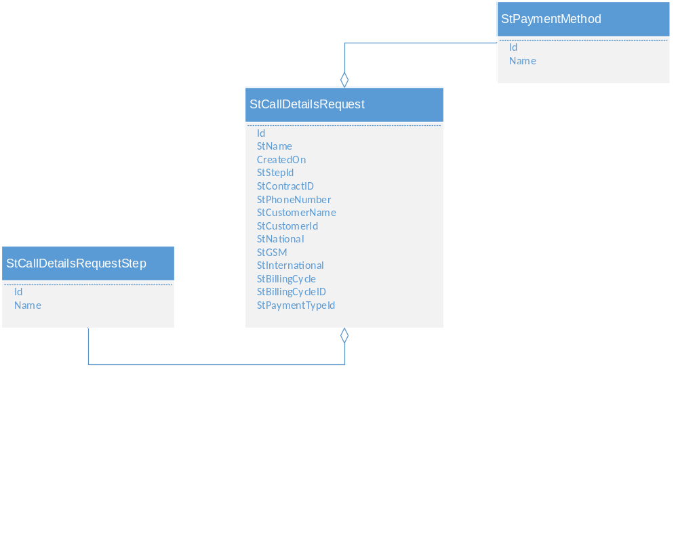
Figure 11- StCallDetailsRequest Table Data Model

Table Details

Table20- StCallDetailsRequest Table Details

Field | Data Type | Constraint | Required | Default | Source
Id | uniqueidentifier | Primary
StName | nvarchar(250)
CreatedOn | datetime2(7)
StStepId | uniqueidentifier | Foreign |  |  | Lookup
StContractID | nvarchar(250) |  |  |  | BSCS
StPhoneNumber | nvarchar(250)
StCustomerName | nvarchar(250) |  |  |  | BSCS
StCustomerId | nvarchar(250) |  |  |  | BSCS
StNational | bit
StGSM | bit
StInternational | bit
StBillingCycle | nvarchar(250) |  |  |  | BSCS
StBillingCycleID | nvarchar(250) |  |  |  | BSCS
StPaymentTypeId | uniqueidentifier | Foreign |  |  | Lookup

Sample Record
Table21- StCallDetailsRequest Table Sample Record

Field | Value | Description
Id | CC9FD2A2-D4A6-4BF2-8C7B-39A79EE3E0C8 | The Id of call detail request
StName | Call Details Request for: CONTR0000000471 | The name of call detail request
CreatedOn | 2018-10-11 12:49 | The creation date and time of call detail request
StStepId | Select Options | In this step, the CSR selects the destination zones of call details records(National, GSM and international) based on customer’s request
StContractID | CONTR0000000471 | The contract Id in BSCS
StPhoneNumber | 011 2234457 | The telephone number in the contract
StCustomerName | Anas Haddad | The name of customer requesting the operation
StCustomerId | CUST0000000885 | The customer public key retrieved from BSCS
StNational | yes | Field-flag to indicates if call details records will include national traffic (calling and called numbers)
StGSM | yes | Field-flag to indicates if call details records will include GSM traffic(calling and called numbers)
StInternational | no | Field flag to indicates if call details records will include international traffic(calling and called numbers)
StBillingCycle | Billcycle_02 | The billing cycle assigned to the customer
StBillingCycleID | Billcycle_02 | The billing cycle Id from BSCS
StPaymentTypeId | Cash | The payment type selected to cover the request’s fee

Lookups

StCallDetailsRequestStep Lookup Table
Value | Description
Select Options | In this stage, the CSR selects the target zones ( GSM, National or International)
Payment | Selecting the payment method step in retrieving calls details process

StPaymentMethod Lookup Table
Value | Description
Cash | The customer pays cash the call details request’s fee
Invoice | The customer pays call details request’s fee on invoice

Contract Takeover Request
This entity represents the process of changing the owner of specific contract to another contact or account for many reasons as migration. If the new customer is not existing, then CSR should create the customer and activate him before proceeding

Data Model

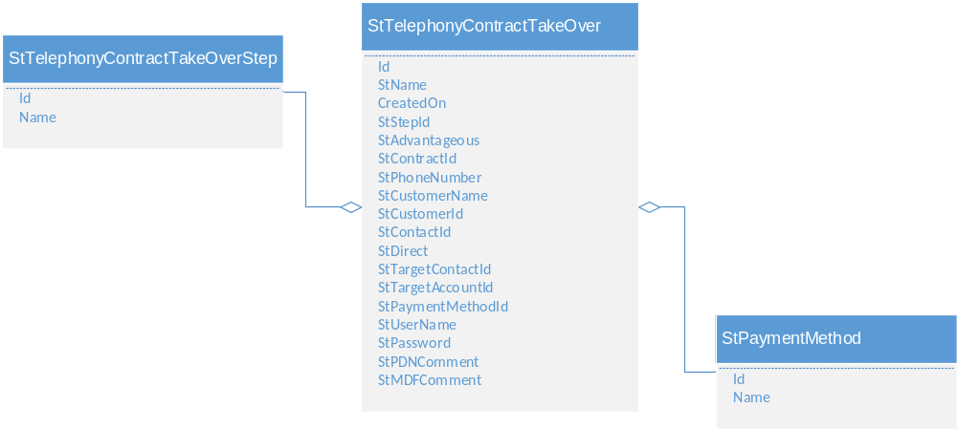

Figure 12- StTelephonyContractTakeOver Table Data Model

Table Details
Table22- StTelephonyContractTakeOver Table Details

Field | Data Type | Constraint | Required | Default | Source
Id | uniqueidentifier | Primary
StName | nvarchar(250)
CreatedOn | datetime2(7)
StStepId | uniqueidentifier | Foreign |  |  | Lookup
StAdvantageous | bit
StContractId | nvarchar(250) |  |  |  | BSCS
StPhoneNumber | nvarchar(250)
StCustomerName | nvarchar(250) |  |  |  | BSCS
StCustomerId | nvarchar(250) |  |  |  | BSCS
StContactId | nvarchar(250)
StDirect | bit
StTargetContactId | uniqueidentifier | Foreign |  |  | Lookup
StTargetAccountId | uniqueidentifier | Foreign |  |  | Lookup
StPaymentMethodId | uniqueidentifier | Foreign |  |  | Lookup
StUserName | nvarchar(250)
StPassword | nvarchar(250)
StPDNComment | nvarchar(250)
StMDFComment | nvarchar(250)

Sample Record
Table23- StTelephonyContractTakeOver Table Sample Record
Field | Value | Description
Id | 5084EDF0-A4FE-47AE-B4EE-C48B782EC6E1 | The Id of contract takeover operation
StName | ContractTakeOver Request for: CONTR0000000541 | The name of contract takeover operation
CreatedOn | 2018-10-26 09:30 | The creation date and time of contract takeover operation
StStepId | Payment | The current step in contract takeover process
StAdvantageous | No | A flag indicating if the operation is advantageous or not
StContractId | CONTR0000000541 | The Id of the contract submitting to the takeover operation and retrieved from BSCS
StPhoneNumber | 011 2223455 | The phone number of the customer
StCustomerName | Anas Haddad | The customer name related to the contract
StCustomerId | CUST0000000955 | The customer public key retrieved from BSCS
StContactId | 82F8E7C9-E5C9-4351-9B5F-012593043C5E | Foreign key from “Contact” table(original owner of the contract )
StDirect | yes | This is a field flag to determine whether the takeover operation is direct or indirect. In case of direct takeover, the two parties are present and sign a waiver document while in case of indirect takeover, only the original owner is present and sign a concession pledge document
StTargetContactId | 70F8A7C9-E5F8-4351-9B7F-54612245C5E | Foreign key from “Contact” table(new owner of the contract)
StTargetAccountId |  | Foreign key from “Account” table
StPaymentMethodId | cash | The payment method chosen to pay contract takeover’s fee

Field | Value | Description
StUserName |  | The username of new ADSL contract if “ADSL takeover” option is selected
StPassword |  | The password of new ADSL contract if “ADSL take over” option is selected
StPDNComment |  | The comments of DPN team if “ADSL take over” option is selected
StMDFComment |  | The comments of MDF team when sending the work order to change the customer name

Lookups

StTelephonyContractTakeOverStep Lookup Table
Value | Description
DPN team | The “Data packet Network” team comments(only if ADSL contract takeover is selected) are written in this step after changing the customer name
Payment | Choosing the payment type step in contract takeover process

StPaymentMethod Lookup Table
Value | Description
Cash | The customer pays cash the call details request
Invoice | The customer pays call details request’s fee on invoice

Friend and Family Entity
This entity represents a service used to define a discount percentage on a dedicated destination numbers (friend and family numbers for example)

Data Model

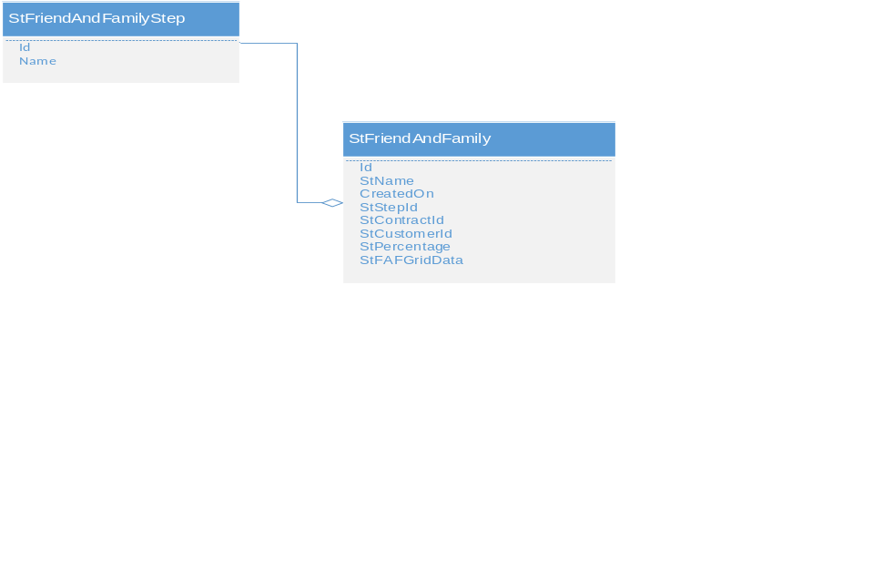

Figure 13- StFriendAndFamily Table Data Model

Table Details
Table24- StFriendAndFamily Table Details

Field | Data Type | Constraint | Required | Default | Source
Id | uniqueidentifier | Primary
StName | nvarchar(250)
CreatedOn | datetime2(7)
StStepId | uniqueidentifier | Foreign |  |  | Lookup
StContractId | nvarchar(250) |  |  |  | BSCS
StCustomerId | nvarchar(250) |  |  |  | BSCS
StPercentage | nvarchar(250)
StFAFGridData | nvarchar(max)

Sample Record
Table25- StFriendAndFamily Table Sample Record

Field | Value | Description
Id
StName
CreatedOn
StStepId
StContractId
StCustomerId |  | The customer public key retrieved from BSCS
StPercentage
StFAFGridData

Lookups

StFriendAndFamilyStep Lookup Table
Value | Description
F&F numbers | This step in “Friend and Family” process allows the CSR to add the telephone numbers and determine the percentage that the customer should pay from service cost. This percentage will be applied on all numbers

CPT Request
This entity represents a service used over ST network to directly associate a 4-digits number to a 7-digits PSTN number for incoming call routing. The dialer can reach the 7-digits by dialing the CPT 4-digits number. This operation is not allowed on PES/WCDMA phone types. Related fees are collected on invoice

Data Model

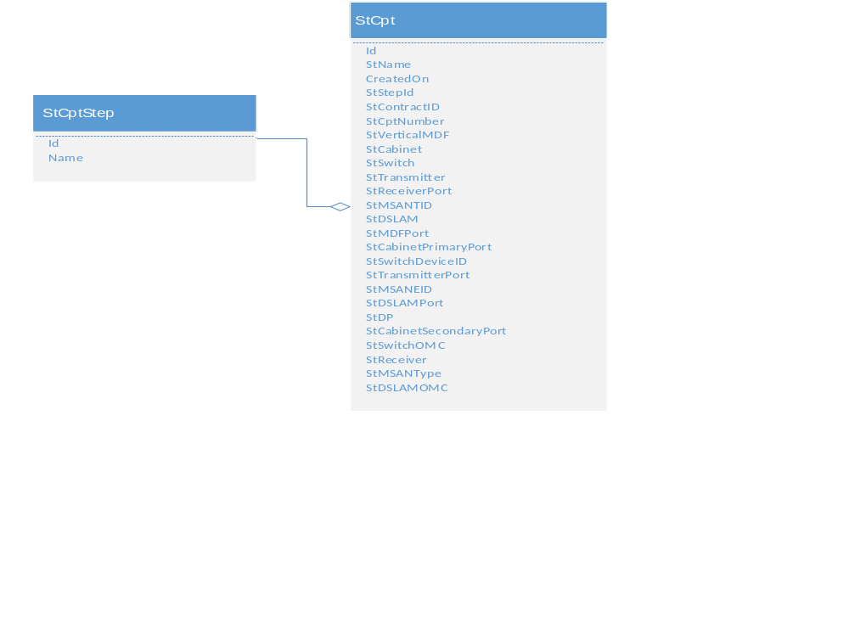

Figure 14- StCp Table Data Model

Table Details
Table26- StCpt Table Details

Field | Data Type | Constraint | Required | Default | Source
Id | uniqueidentifier | Primary
StName | nvarchar(250)
CreatedOn | datetime2(7)
StStepId | uniqueidentifier | Foreign |  |  | Lookup
StContractID | nvarchar(250) |  |  |  | BSCS
StCptNumber | nvarchar(250) |  |  |  | Inventory
StVerticalMDF | nvarchar(250) |  |  |  | Inventory
StCabinet | nvarchar(250) |  |  |  | Inventory
StSwitch | nvarchar(250) |  |  |  | Inventory
StTransmitter | nvarchar(250) |  |  |  | Inventory
StReceiverPort | nvarchar(250) |  |  |  | Inventory
StMSANTID | nvarchar(250) |  |  |  | Inventory
StDSLAM | nvarchar(250) |  |  |  | Inventory
StMDFPort | nvarchar(250) |  |  |  | Inventory
StCabinetPrimaryPort | nvarchar(250) |  |  |  | Inventory
StSwitchDeviceID | nvarchar(250) |  |  |  | Inventory
StTransmitterPort | nvarchar(250) |  |  |  | Inventory
StMSANEID | nvarchar(250) |  |  |  | Inventory
StDSLAMPort | nvarchar(250) |  |  |  | Inventory
StDP | nvarchar(250) |  |  |  | Inventory
StCabinetSecondaryPort | nvarchar(250) |  |  |  | Inventory
StSwitchOMC | nvarchar(250) |  |  |  | Inventory
StReceiver | nvarchar(250) |  |  |  | Inventory
StMSANType | nvarchar(250) |  |  |  | Inventory
StDSLAMOMC | nvarchar(250) |  |  |  | Inventory

Sample Record
Table27- StCpt Table Sample Record
Field | Value | Description
Id | 123629F9-2359-4272-89D3-03DDFF1DE31C | The Id of CPT request
StName | Create Cpt Request for: CONTR0000000447 | The name of CPT request
CreatedOn | 2018-10-29 16:11 | The creation date and time of CPT request
StStepId | Reserve Number | The step of reserving free CPT number in activation CPT service
StContractID | CONTR0000000447 | The contract Id related to the number submitting to CPT service activation
StCptNumber | 4579 | Reserved CPT number
StVerticalMDF |  | Vertical MDF related to the number submitting to CPT service activation
StCabinet |  | Cabinet related to the number submitting to CPT service activation
StSwitch |  | Switch related to the number submitting to CPT service activation
StTransmitter |  | Transmitter related to the number submitting to CPT service activation
StReceiverPort |  | Receiver port related to the number submitting to CPT service activation
StMSANTID |  | MSAN terminal Id related to the number submitting to CPT service activation
StDSLAM |  | DSL access multiplexer related to the number submitting to CPT service activation
StMDFPort |  | MDF port related to the number submitting to CPT service activation
StCabinetPrimaryPort |  | Cabinet’s primary port related to the number submitting to CPT service activation
StSwitchDeviceID |  | Switch device Id related to the number submitting to CPT service activation
StTransmitterPort |  | Transmitter port related to the number submitting to CPT service activation

Field | Value | Description
StMSANEID |  | MSAN equipment Id related to the number submitting to CPT service activation
StDSLAMPort |  | DSL access multiplexer’s port related to the number submitting to CPT service activation
StDP |  | DP related to the number submitting to CPT service activation
StCabinetSecondaryPort |  | Cabinet’s secondary port’s related to the number submitting to CPT service activation
StSwitchOMC |  | Switch OMC related to the number submitting to CPT service activation
StReceiver |  | Receiver related to the number submitting to CPT service activation
StMSANType |  | MSAN type related to the number submitting to CPT service activation
StDSLAMOMC |  | DSL access multiplexer’s OMC related to the number submitting to CPT service activation

Lookups

StCptStep Lookup Table
Value | Description
Reserve Number | In this step, CSR chooses a free CPT number and reserve it
OMC team | This step allows OMC team to check technical description for the line submitting to CPT service activation

Deactivate CPT Request
This entity represents the case when the user wants to deactivate CPT Service. CRM notifies the user for confirmation and CSR adds comments and attachments before sending the request to technical team

Data Model
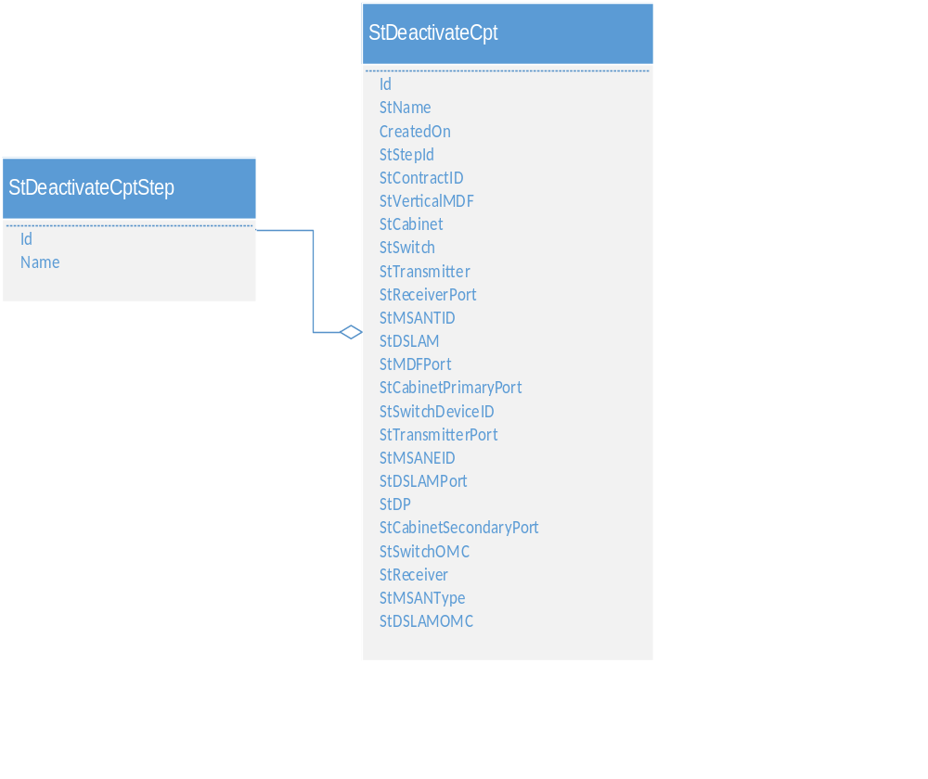 Figure 14- StDeactivateCpt Table Data Model

Table Details
Table28- StDeactivateCpt Table Details

Field | Data Type | Constraint | Required | Default | Source
Id | uniqueidentifier | Primary
StName | nvarchar(250)
CreatedOn | datetime2(7)
StStepId | uniqueidentifier | Foreign |  |  | Lookup
StContractID | nvarchar(250) |  |  |  | BSCS
StVerticalMDF | nvarchar(250) |  |  |  | Inventory
StCabinet | nvarchar(250) |  |  |  | Inventory
StSwitch | nvarchar(250) |  |  |  | Inventory
StTransmitter | nvarchar(250) |  |  |  | Inventory
StReceiverPort | nvarchar(250) |  |  |  | Inventory
StMSANTID | nvarchar(250) |  |  |  | Inventory
StDSLAM | nvarchar(250) |  |  |  | Inventory
StMDFPort | nvarchar(250) |  |  |  | Inventory
StCabinetPrimaryPort | nvarchar(250) |  |  |  | Inventory
StSwitchDeviceID | nvarchar(250) |  |  |  | Inventory
StTransmitterPort | nvarchar(250) |  |  |  | Inventory
StMSANEID | nvarchar(250) |  |  |  | Inventory
StDSLAMPort | nvarchar(250) |  |  |  | Inventory
StDP | nvarchar(250) |  |  |  | Inventory
StCabinetSecondaryPort | nvarchar(250) |  |  |  | Inventory
StSwitchOMC | nvarchar(250) |  |  |  | Inventory
StReceiver | nvarchar(250) |  |  |  | Inventory
StMSANType | nvarchar(250) |  |  |  | Inventory
StDSLAMOMC | nvarchar(250) |  |  |  | Inventory

Sample Record
Table29- StDeactivateCpt Table Sample Record
Field | Value | Description
Id | 123629F9-2359-4272-89D3-03DDFF1DE31C | The Id of deactivate CPT request
StName | Create Cpt Request for: CONTR0000000448 | The name of deactivate CPT request
CreatedOn | 2018-10-30 16:11 | The creation date and time of deactivate CPT request
StStepId | OMC team | Sending work order and technical description to OMC team
StContractID | CONTR0000000448 | The contract Id related to the number submitting to CPT service deactivation
StVerticalMDF |  | Vertical MDF related to the number submitting to CPT service deactivation
StCabinet |  | Cabinet related to the number submitting to CPT service deactivation
StSwitch |  | Switch related to the number submitting to CPT service deactivation
StTransmitter |  | Transmitter related to the number submitting to CPT service deactivation
StReceiverPort |  | Receiver port related to the number submitting to CPT service deactivation
StMSANTID |  | MSAN terminal Id related to the number submitting to CPT service deactivation
StDSLAM |  | DSL access multiplexer related to the number submitting to CPT service deactivation
StMDFPort |  | MDF port related to the number submitting to CPT service deactivation
StCabinetPrimaryPort |  | Cabinet’s primary port related to the number submitting to CPT service deactivation
StSwitchDeviceID |  | Switch device Id related to the number submitting to CPT service deactivation
StTransmitterPort |  | Transmitter port related to the number submitting to CPT service deactivation

Field | Value | Description
StMSANEID |  | MSAN equipment Id related to the number submitting to CPT service deactivation
StDSLAMPort |  | DSL access multiplexer’s port related to the number submitting to CPT service deactivation
StDP |  | DP related to the number submitting to CPT service deactivation
StCabinetSecondaryPort |  | Cabinet’s secondary port’s related to the number submitting to CPT service deactivation
StSwitchOMC |  | Switch OMC related to the number submitting to CPT service deactivation
StReceiver |  | Receiver related to the number submitting to CPT service deactivation
StMSANType |  | MSAN type related to the number submitting to CPT service deactivation
StDSLAMOMC |  | DSL access multiplexer’s OMC related to the number submitting to CPT service deactivation

Lookups

StDeactivateCptStep Lookup Table
Value | Description
OMC team | This step allows OMC team to check technical description for the line submitting to CPT service deactivation
Print | CSR prints the document related to CPT deactivation request

Deported Number Entity
This entity shows the case when the customer moves to a different location but he want to keep his telephone number which means a line moving new switch request but without changing the phone number .

Data Model

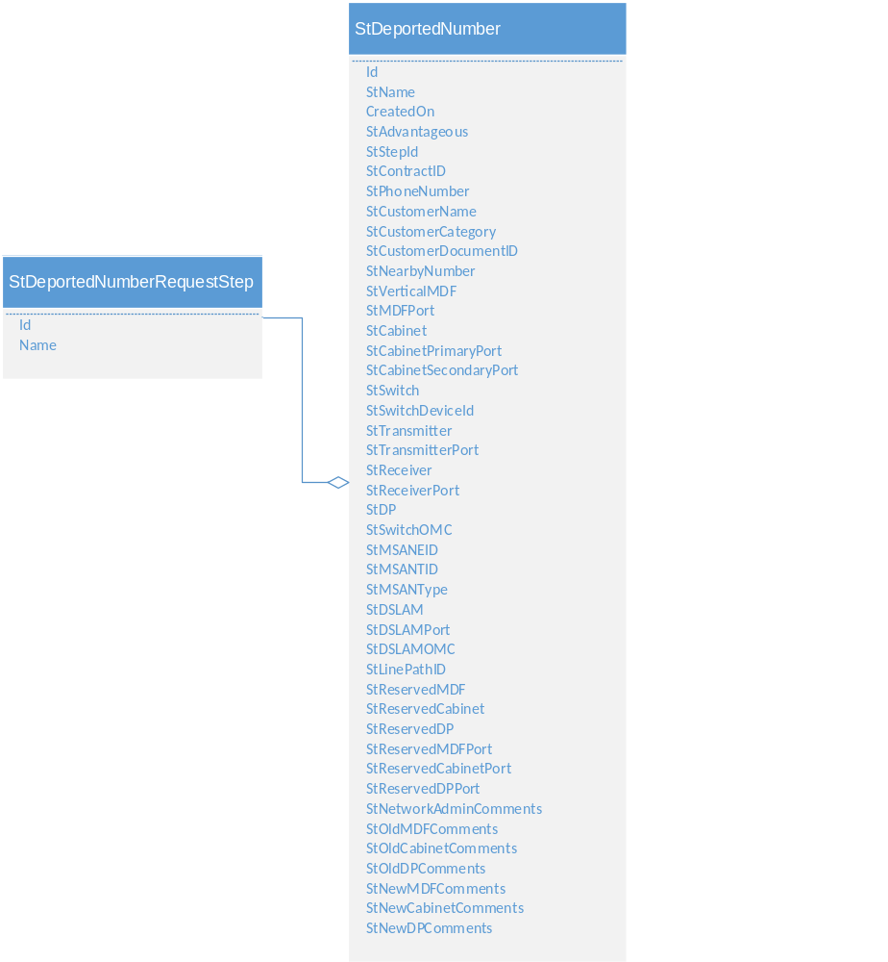
Figure 15- StDeportedNumber Table Data Model

Table Details
Table30- StDeportedNumber Table Details
Field | Data Type | Constraint | Required | Default | Source
Id | uniqueidentifier | Primary
StName | nvarchar(250)
CreatedOn | datetime2(7)
StAdvantageous | bit
StStepId | uniqueidentifier | Foreign |  |  | Lookup
StContractID | nvarchar(250) |  |  |  | BSCS
StPhoneNumber | nvarchar(250)
StCustomerName | nvarchar(250)
StCustomerCategory | nvarchar(250) |  |  |  | BSCS
StCustomerDocumentID | nvarchar(250) |  |  |  | BSCS
StNearbyNumber | nvarchar(250) |  |  |  | nventory
StVerticalMDF | nvarchar(250) |  |  |  | Inventory
StCabinet | nvarchar(250) |  |  |  | Inventory
StSwitch | nvarchar(250) |  |  |  | Inventory
StTransmitter | nvarchar(250) |  |  |  | Inventory
StReceiverPort | nvarchar(250) |  |  |  | Inventory
StMSANTID | nvarchar(250) |  |  |  | Inventory
StDSLAM | nvarchar(250) |  |  |  | Inventory
StMDFPort | nvarchar(250) |  |  |  | Inventory
StCabinetPrimaryPort | nvarchar(250) |  |  |  | Inventory
StSwitchDeviceId | nvarchar(250) |  |  |  | Inventory
StTransmitterPort | nvarchar(250) |  |  |  | Inventory
StMSANEID | nvarchar(250) |  |  |  | Inventory
StDSLAMPort | nvarchar(250) |  |  |  | Inventory

Field | Data Type | Constraint | Required | Default | Source
StDP | nvarchar(250) |  |  |  | Inventory
StCabinetSecondaryPort | nvarchar(250) |  |  |  | Inventory
StSwitchOMC | nvarchar(250) |  |  |  | Inventory
StReceiver | nvarchar(250) |  |  |  | Inventory
StMSANType | nvarchar(250) |  |  |  | Inventory
StDSLAMOMC | nvarchar(250) |  |  |  | Inventory
StLinePathID | nvarchar(250) |  |  |  | Inventory
StReservedMDF | nvarchar(250) |  |  |  | Inventory
StReservedCabinet | nvarchar(250) |  |  |  | Inventory
StReservedDP | nvarchar(250) |  |  |  | Inventory
StReservedMDFPort | nvarchar(250) |  |  |  | Inventory
StReservedCabinetPort | nvarchar(250) |  |  |  | Inventory
StReservedDPPort | nvarchar(250) |  |  |  | Inventory
StNetworkAdminComments | nvarchar(250)
StOldMDFComments | nvarchar(250)
StOldCabinetComments | nvarchar(250)
StOldDPComments | nvarchar(250)
StNewMDFComments | nvarchar(250)
StNewCabinetComments | nvarchar(250)
StNewDPComments | nvarchar(250)

Sample Record
Table31- StDeportedNumber Table Sample Record (RO indicates Read Only)
Field | Value | Description
Id | 7A1C9CD4-E845-4FEB-93D9-652943E84814 | The Id of deported number request
StName | Create Cpt Request for: CONTR0000000681 | The name of deactivate CPT request
CreatedOn | 2018-10-30 09:50 | The creation date and time of deactivate CPT request
StAdvantageous | No | Flag indicates if the operation is advantageous or not
StStepId | MIC Team
StContractID | CONTR0000000681 | The contract Id related to the deported number request
StPhoneNumber | 011 8845571 | The phone number related to the contract
StCustomerName | Hasan Ibrahim | The customer name relate to the contract submitting to deported number request
StCustomerCategory | Official | The customer category from BSCS
StCustomerDocumentID | 57235918564 | The Id of the chosen document type (here the personal Identity number)
StNearbyNumber | 011 7445216 | The nearby phone number given by the customer related to his new address
StVerticalMDF(RO) | 001 | Vertical MDF related to the nearby number
StMDFPort(RO) | P001 | MDF port related to the nearby number
StCabinet(RO) | Allepo001.CAB | Cabinet related to the nearby number
StCabinetPrimaryPort(RO) |  | Cabinet’s primary port related to the nearby number
StCabinetSecondaryPort(RO) |  | Cabinet’s secondary port related to the nearby number
StSwitch(RO) | Allepo.SW | Switch related to the nearby number
StSwitchDeviceId(RO) | 591.0 | Switch’s device Id related to the nearby number
StTransmitter(RO) | 0 | Transmitter related to the nearby number
StTransmitterPort(RO) |  | Transmitter’s port related to the nearby number
StReceiver(RO) | 0 | Receiver related to the nearby number
StReceiverPort(RO) | 0 | Receiver’s port related to the nearby number

Field | Value | Description
StDP(RO) | Allepo001.DP | DP related to the nearby number
StSwitchOMC(RO) | Ericsson | Switch OMC related to the nearby number
StMSANEID(RO) |  | MSAN equipment Id related to the nearby number
StMSANTID(RO) |  | MSAN terminal Id related to the nearby number
StMSANType(RO) |  | MSAN type related to the nearby number
StDSLAM(RO) |  | DSL access multiplexer related to the nearby number
StDSLAMPort(RO) |  | DSL access multiplexer’s port related to the nearby number
StDSLAMOMC(RO) |  | DSL access multiplexer’s OMC related to the nearby number
StLinePathID(RO) | f58640e7-ea52-44d3-81c3-30fb2b91a8b9 | Line path Id got from XAKTA related to the free reservation in the new location
StReservedMDF(RO) | MDF001 | MDF related to the free reservation in the new location
StReservedCabinet(RO) | Cabinet002 | Cabinet related to the free reservation in the new location
StReservedDP(RO) | DP003 | DP related to the free reservation in the new location
StReservedMDFPort(RO) | 005 | MDF port related to the free reservation in the new location
StReservedCabinetPort(RO) | 004 | MDF port related to the free reservation in the new location
StReservedDPPort(RO) | 005 | DP port related to the free reservation in the new location
StNetworkAdminComments |  | Comments written by network admin after making reservation on the generated path Id using XAKTA and planning the connection between MDFs and MICs in order to reach the old switch from the new reservation
StOldMDFComments |  | Comments written by old MDF team after releasing the old reservation
StOldCabinetComments |  | Comments written by the old cabinet team after releasing the old reservation
StOldDPComments |  | Comments written by the old DP team after releasing the old reservation

Field | Value | Description
StNewMDFComments |  | Comments written by new MDF team in the new switch after plugging the reserved port in MDF from MIC side and make the cabling in MDF to customer side
StNewCabinetComments |  | Comments written by new cabinet team after plugging the reserved port in cabinet
StNewDPComments |  | Comments written by new DP team after plugging the reserved port in DP

Lookups

StDeportedNumberRequestStep Lookup Table
Value | Description
Reservation | This is the step of finding free reservation related to the new location and getting a new line path Id using XAKTA system
Network Admin | In this step of deported number process, the network admin team checks path Id, makes the reservation on it using XAKTA system and plans the connections between MICs and MDFs in order to reach the old switch from the new reservation

Add OCC entity
This entity represents an operation allowed only by the accounting team which is adding OCC (other charges and credits) on a contract billing account due to specific reasons.

Data Model

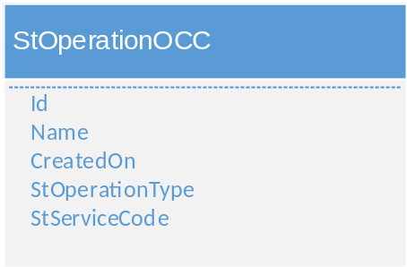

Figure 16- StOperationOCC Table Data Model

Table Details
Table32- StOperationOCC Table Details
Field | Data Type | Constraint | Required | Default | Source
Id | uniqueidentifier | Primary
StName | nvarchar(250)
CreatedOn | datetime2(7)
StOperationType | nvarchar(50)
StServiceCode | nvarchar(50)

Sample Records
Table33- StOperationOCC Table Sample Record (RO indicates read-only)
Field | Value | Description
Id |  | The Id of OCC operation
StName |  | The name of OCC operation
CreatedOn |  | The creation date and time of OCC operation
StOperationType
StServiceCode |  | The code of service from BSCS

Lookups
Currently there is no lookups for this entity.

Create PABX Service Entity
This entity represents the creation of PABX service for a specific contract. PABX is an ST Service that enables the customer to have a virtual switch between different numbers created in ST switch, provided that all phone numbers should be related to the same switch and same customer. This operation is not allowed if PABX is already active on the contract and if the customer balance is positive

Data Model

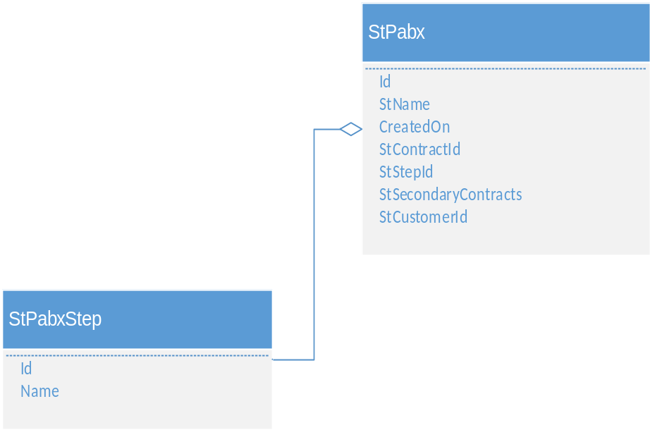

Figure 17- StPabx Table Data Model

Table Details
Table34- StPabx Table Details
Field | Data Type | Constraint | Required | Default | Source
Id | uniqueidentifier | Primary
StName | nvarchar(250)
CreatedOn | datetime2(7)
StContractId | nvarchar(250) |  |  |  | BSCS
StStepId | uniqueidentifier | Foreign |  |  | Lookup
StSecondaryContracts | nvarchar(max) |  |  |  | BSCS
StCustomerId | nvarchar(250) |  |  |  | BSCS

Sample Record
Table35- StPabx Table Sample Record (RO indicates read-only)
Field | Value | Description
Id | B87C758F-A36F-45BC-8E76-D403EDDFA75A | The id of PABX request
StName | Create Pabx Request for: CONTR0000000564 | The name of PABX request
CreatedOn | 2018-10-30 07:46 | The creation date and time of PABX request
StContractId | CONTR0000000564 | The Id of the contract from BSCS submitting to PABX request
StStepId | Reserve Numbers | This field shows the current step in creating PABX service

Field | Value | Description
StSecondaryContracts | [{"ContractId":"CONTR0000000587}","CustomerId":"CUST0000000881","PhoneNumber":"0114578141","Address":"Hamra","PabxOption":"0"}] | This field contains a list for selection of secondary telephony contracts related to the same switch of the pilot number and same customer requesting PABX
StCustomerId | CUST0000000881 | The customer public key retrieved from BSCS

Lookups

StPabxStep Lookup Table
Value | Description
Switch team | This step exists in case of manual switch where the team activates the PABX service on the switch
Print | CSR prints the document related to PABX creation request
Reserve Numbers | In this step, the CSR selects an option from a list of other active telephony contracts related to the customer and the pilot number’s switch and then selects the list of secondary numbers

Manage PABX Entity
This entity is related to the case when the contact wants to add a new telephony contract to the existing PABX service or to update the options of already created secondary lines (make call, receive call or both).

Data Model

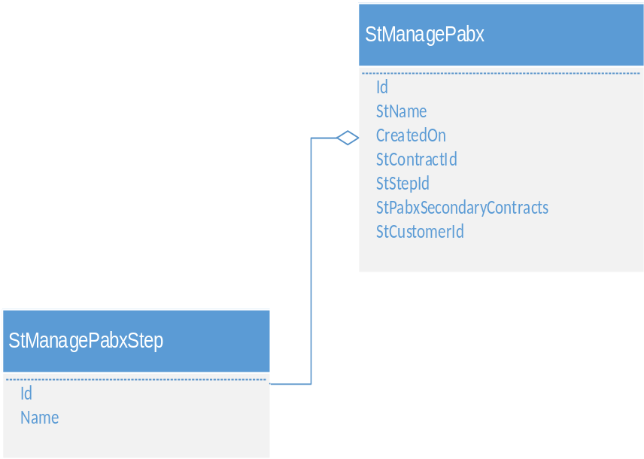

Figure 18- StManagePabx Table Data Model

Table Details
Table36- StManagePabx Table Details
Field | Data Type | Constraint | Required | Default | Source
Id | uniqueidentifier | Primary
StName | nvarchar(250)
CreatedOn | datetime2(7)
StContractId | nvarchar(250) |  |  |  | BSCS
StStepId | uniqueidentifier | Foreign |  |  | Lookup
StPabxSecondaryContracts | nvarchar(max) |  |  |  | BSCS
StCustomerId | nvarchar(500) |  |  |  | BSCS

Sample Record
Table37- StManagePabx Table Sample Record (RO indicates read-only)
Field | Value | Description
Id | 89489734-BF4B-4078-B75B-1FA13D11DCB9 | The id of PABX editing request
StName | Edit Pabx Request for: CONTR0000000601 | The name of PABX editing request
CreatedOn | 2018-11-10 09:50 | The creation date and time of PABX edit request
StContractId | CONTR0000000601 | The Id of the contract from BSCS submitting to PABX edit request
StStepId | Manage Contracts | This field shows the current step in edit PABX service

Field | Value | Description
StPabxSecondaryContracts | [{"ContractId":"CONTR0000000587}","CustomerId":"CUST0000000990","PhoneNumber":"0114578141","Address":"Hamra","PabxOption":"0"}] | This field contains a list for selection of secondary telephony contracts related to the same switch of the pilot number and same customer requesting PABX edit
StCustomerId | CUST0000000990 | The customer public key retrieved from BSCS

Lookups

StManagePabxStep Lookup Table
Value | Description
Switch team | This step exists in case of manual switch where the team activates the PABX service on the switch
Manage Contracts | In this step, the CSR is able to add a new telephony contract from a list of active telephony contracts with the options “Make call”, “receive call” or “both” or to update the options of already created ones

Deactivate PABX Entity
This entity represents the deactivation of PABX service upon a customer’s request.

Data Model

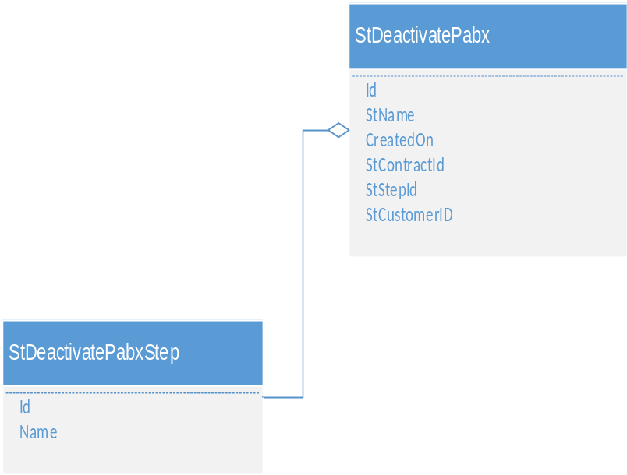

Figure 19- StDeactivatePabx Table Data Model

Table Details
Table38- StDeactivatePabx Table Details
Field | Data Type | Constraint | Required | Default | Source
Id | uniqueidentifier | Primary
StName | nvarchar(250)
CreatedOn | datetime2(7)
StContractId | nvarchar(250) |  |  |  | BSCS
StStepId | uniqueidentifier | Foreign |  |  | Lookup
StCustomerID | nvarchar(250) |  |  |  | BSCS

Sample Record
Table39- StDeactivatePabx Table Sample Record (RO indicates read-only)
Field | Value | Description
Id | 6F45FFF3-CE3C-448B-B0FC-238EBC3E87EF | The id of PABX deactivation request
StName | deactivate Pabx Request for: CONTR0000000601 | The name of PABX deactivation request
CreatedOn | 2018-12-23 13:50 | The creation date and time of PABX deactivation request
StContractId | CONTR0000000601 | The Id of the contract from BSCS submitting to PABX deactivation request
StStepId | PBX Deactivation | This field shows the current step in deactivate PABX service.
StCustomerID | CUST0000000741 | The customer public key retrieved from BSCS

Lookups

StDeactivatePabxStep Lookup Table
Value | Description
Switch team | This step exists in case of manual switch where the team deactivates the PABX service on the switch
PBX Deactivation | In this step, the pilot number and the secondary numbers are displayed with their devices Ids to allow the CSR to post the request to OM

ISP ADSL Entity
This entity represents the case when the customer wants to add ADSL service to his telephony line from and internet service provider other than ST.

Data Model

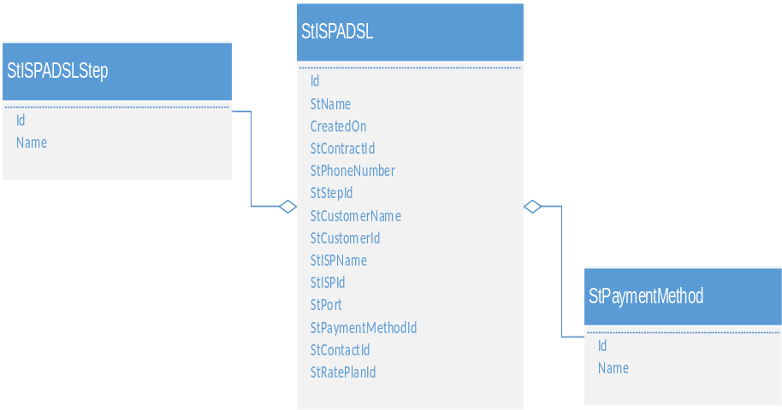

Figure 20- StISPADSL Table Data Model

Table Details
Table40- StISPADSL Table Details
Field | Data Type | Constraint | Required | Default | Source
Id | uniqueidentifier | Primary
StName | nvarchar(250)
CreatedOn | datetime2(7)
StContractId | nvarchar(250) |  |  |  | BSCS
StPhoneNumber | nvarchar(250)
StStepId | uniqueidentifier | Foreign |  |  | Lookup
StCustomerName | nvarchar(max) |  |  |  | BSCS
StCustomerId | nvarchar(500) |  |  |  | BSCS
StISPName | nvarchar(250) |  |  |  | Inventory
StISPId | nvarchar(250) |  |  |  | Inventory
StPort | nvarchar(250) |  |  |  | Inventory
StPaymentMethodId | uniqueidentifier | Foreign |  |  | Lookup
StContactId | nvarchar(250)
StRatePlanId | nvarchar(250) |  |  |  | BSCS

Sample Record
Table41- StISPADSL Table Sample Record (RO indicates read-only)
Field | Value | Description
Id | 9A336672-B55D-4C03-9C90-C5BE8161A738 | The id of ADSL ISP request
StName | Add ADSL ISP Request for: CONTR0000000712 | The name of ADSL ISP request
CreatedOn | 2018-09-29 12:50 | The creation date and time of ADSL ISP request

Field | Value | Description
StContractId | CONTR0000000789 | The contract Id submitting to ADSL ISP request
StPhoneNumber | 011 2254147 | The telephone number related to the contract submitting to ADSL ISP request
StStepId | MDF Team | The current step in ADSL ISP adding process
StCustomerName | Ahmad Hasan | The customer name requesting the ADSL ISP service
StCustomerId | CUST0000000622 | The customer public key retrieved from BSCS
StISPName | Terranet | This field contains a list of available ISPs fetched from inventory
StISPId | 290998CB-5A66-46A5-869B-DBD35BF6588D | ISP Id from inventory
StPort | 003 | A free port related to the selected ISP
StPaymentMethodId | Cash | This field shows the payment method selected to cover ADSL ISP service’s fee
StContactId | 18a08356-101d-4296-a94c-c349835dffa7 | The Id of the contact requesting the ADSL ISP service. This is a foreign key from “Contact” table
StRatePlanId

Lookups

StISPADSLStep Lookup Table
Value | Description
Request ISP | In this step, the CSR requests an ISP name from a list of available ISPs defined in inventory
Port Reservation | In this step, the CSR selects a free port for reservation related to the selected ISP

StPaymentMethod Lookup Table
Value | Description
Cash | The customer pays cash ADSL ISP request’s fee
Invoice | The customer pays ADSL ISP request’s fee on invoice

Appendix

Definitions, Acronyms and Abbreviations

LLD | Low Level Design
ST | Syria Telecom

